Foodbox

Background of the problem statement:

Foodbox is a restaurant chain that delivers food items of different cuisines at affordable prices. They decided to hire a Full Stack developer to develop an online food delivery web application with a rich and user-friendly interface.

You are hired as the Full Stack Java developer and are asked to develop the web application. The management team has provided you with the requirements and their business model so that you can easily arrange different components of the application.

Features of the application:

* Registration
* Login
* Payment gateway
* Searching
* Filtering
* Sorting
* Dynamic data
* Responsive and compatible with different devices

Recommended technologies:

* Database management: MySQL and Oracle
* Backend logic: Java programming, NodeJS
* Frontend development: JSP, Angular, Bootstrap, HTML/CSS, and Javascript
* Automation and testing technologies: Selenium, Jasmine, and TestNG
* DevOps and production technologies: Git, GitHub, Jenkins, Docker, Kubernetes, and AWS

Admin Portal:

* The admin portal deals with all the backend data generation and product information. The admin user should be able to:
* Add or remove different cuisines to or from the application to build a rich product line
* Edit food item details like name, price, cuisine, description, and offers to keep it aligned to the current prices
* Enable or disable the food items

User Portal:

It deals with the user activities. The end-user should be able to:

Sign-in to the application to maintain a record of activities

Search for food items based on the search keyword

Apply filters and sort results based on different cuisines to get the best deals

Add all the selected food items to a cart and customize the purchase at the end

Perform a seamless payment process

sprint planning:

|  |  |  |  |  |
| --- | --- | --- | --- | --- |
| **Epic** | **Feature/ Titel** | **User Story** | **Story Points** | **Sprint** |
| **Foodbox** | All visitors can browse all the items and can search items | * As a first-time visitor to the Foodbox website, I want to browse all the items * I want to be able to search for a specific food item so that I can decide whether to register to buy items. * I want get all items according to increasing or decreasing price order | 3 | 1 |
| New user can register on the Website | * As a register user on the Foodbox website, I want to be able to log in on the website. * As a first-time visitor to the Foodbox website, I want to be able to register on the website. | 4 | 1 |
| Register user can add items to the cart | * As a Register user, I want to be able to add items to the cart * I want to change quantity of an item in the cart, or completely remove one item form the cart. * I want to see the total price as well as the individual price of the items along with unit price. | 8 | 2 |
| Register user can make purchase the added items in the cart | * As a register user, I want to make payments to buy the items added to the cart. * I want to give my Shipping-address, billing-address and credit-card information. * I want a final total cost and get a conformation upon a successful purchase. | 8 | 3 |
| Login as an Admin and can maintain the items and categories | * As an Admin, I want to login. * I want to update a product, or can make an item unavailable for user, * I want to add new item and new categories. | 8 | 4 |

User Portal:

User can visit the website and browse the Food items.

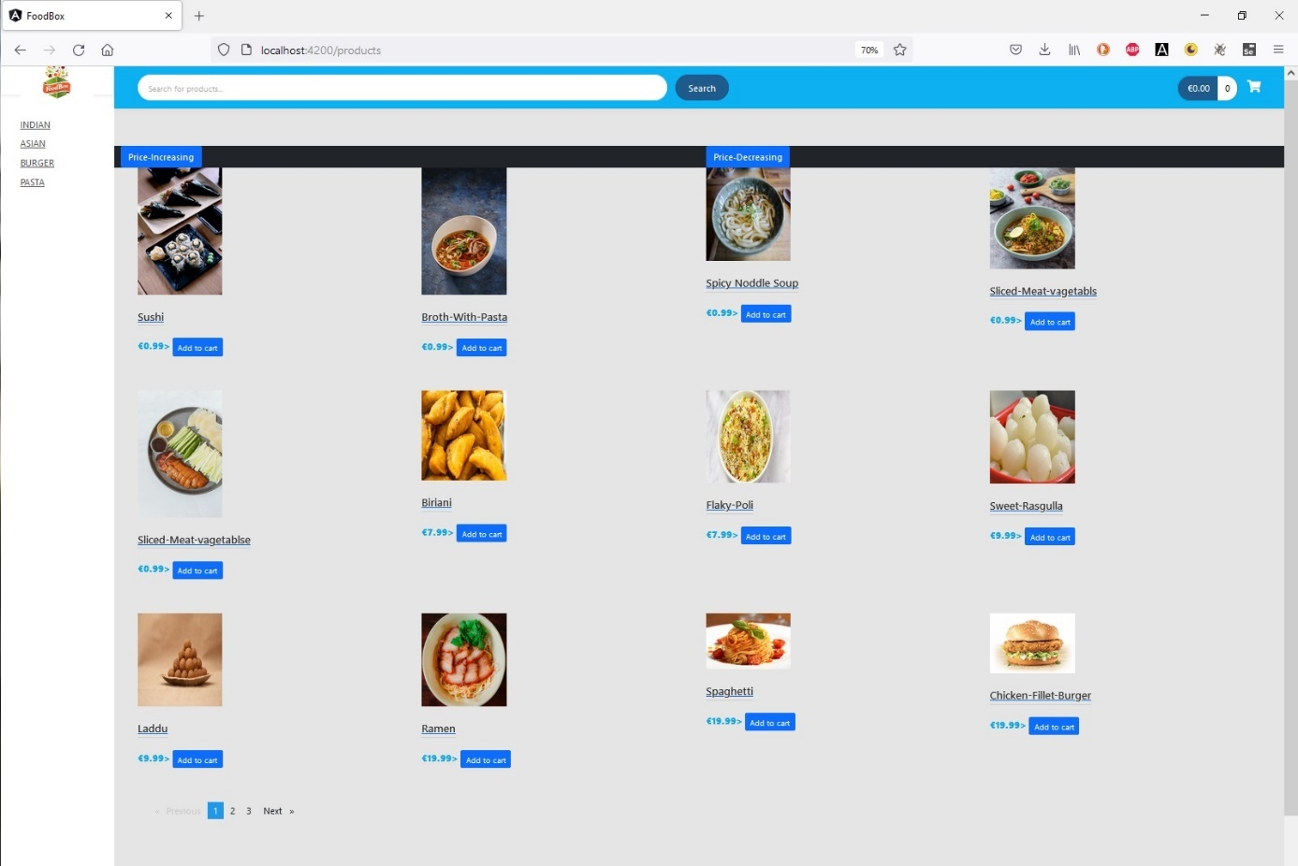

Figure 1:User portal with pagination -on the first page

User can browse the second page as it is shown in figure 2:

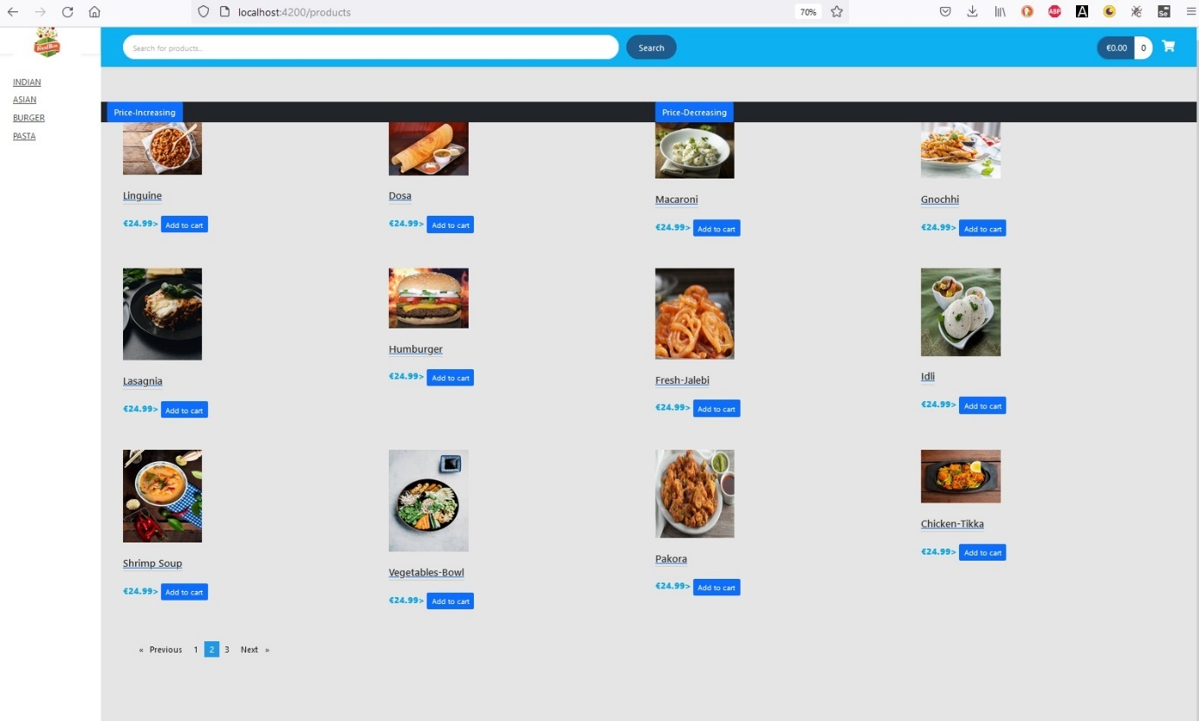

Figure 2:User portal with pagination -on the second page

User can filter the product according to product-category. Figure 3 and show that -with the product category one can filter the food items.

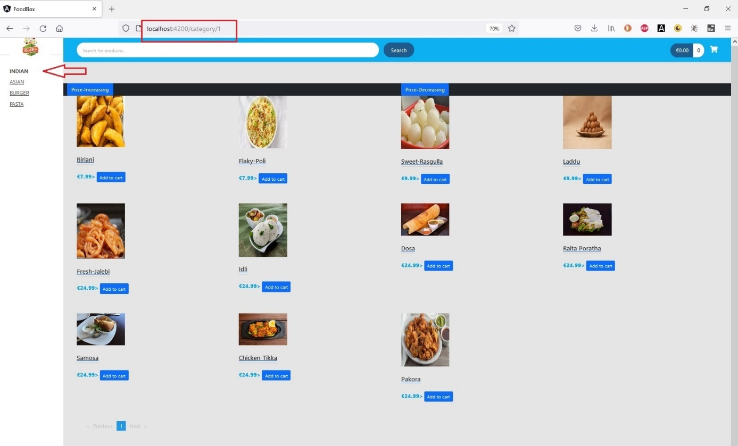

Figure 3:Products filtered with the category name -INDIAN

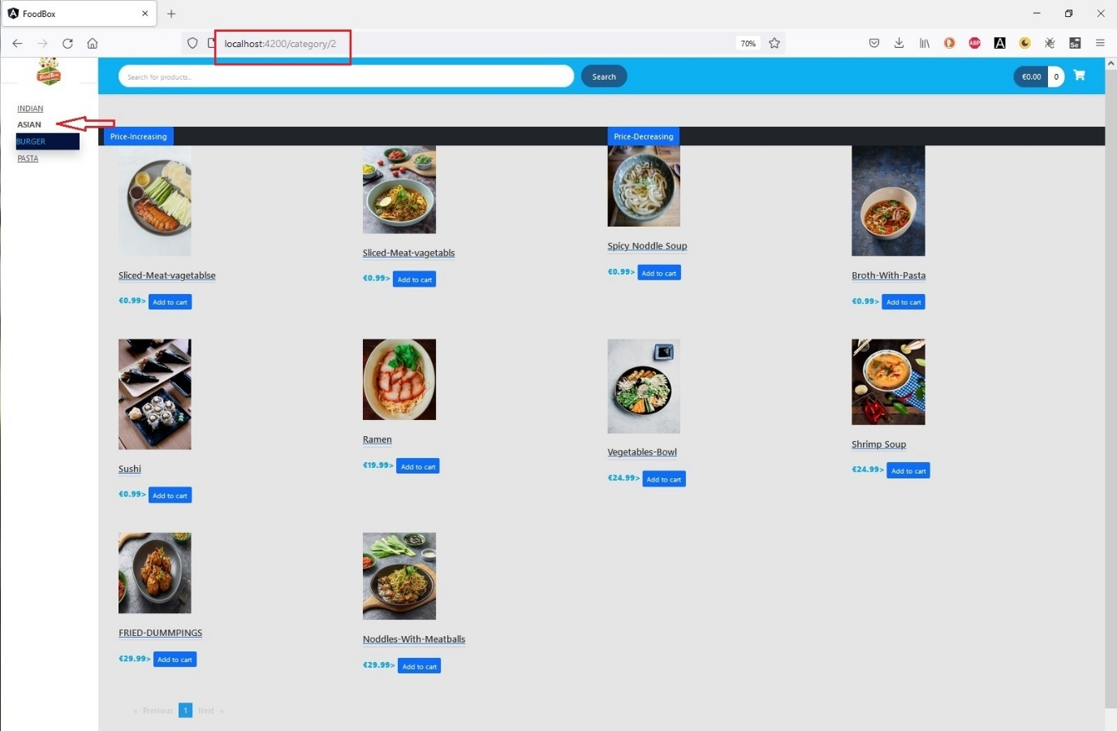

Figure 4::Products filtered with the product category name -Asian

Search: User can search a desired item in the search bar. The outcome of a search operation can be seen in figure 5, where with the search-word “chicken” is being searched.

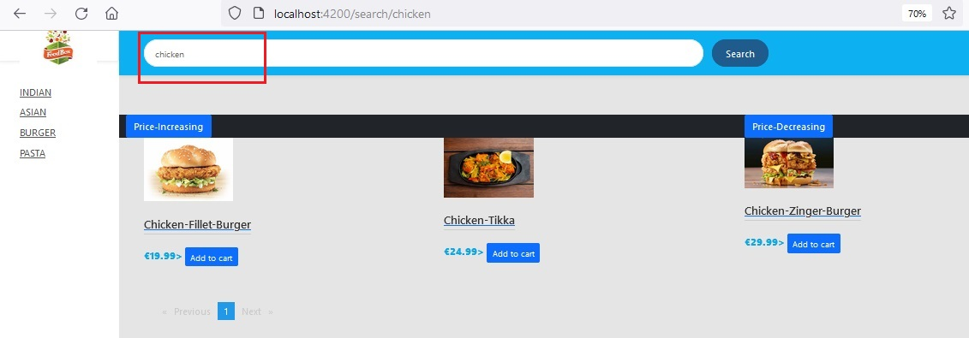

Figure 5:Search an item with search keyword

Sort: User can sort items according to price in ascending or descending order. Figures 6 and 7 show the sorting of item according to price.

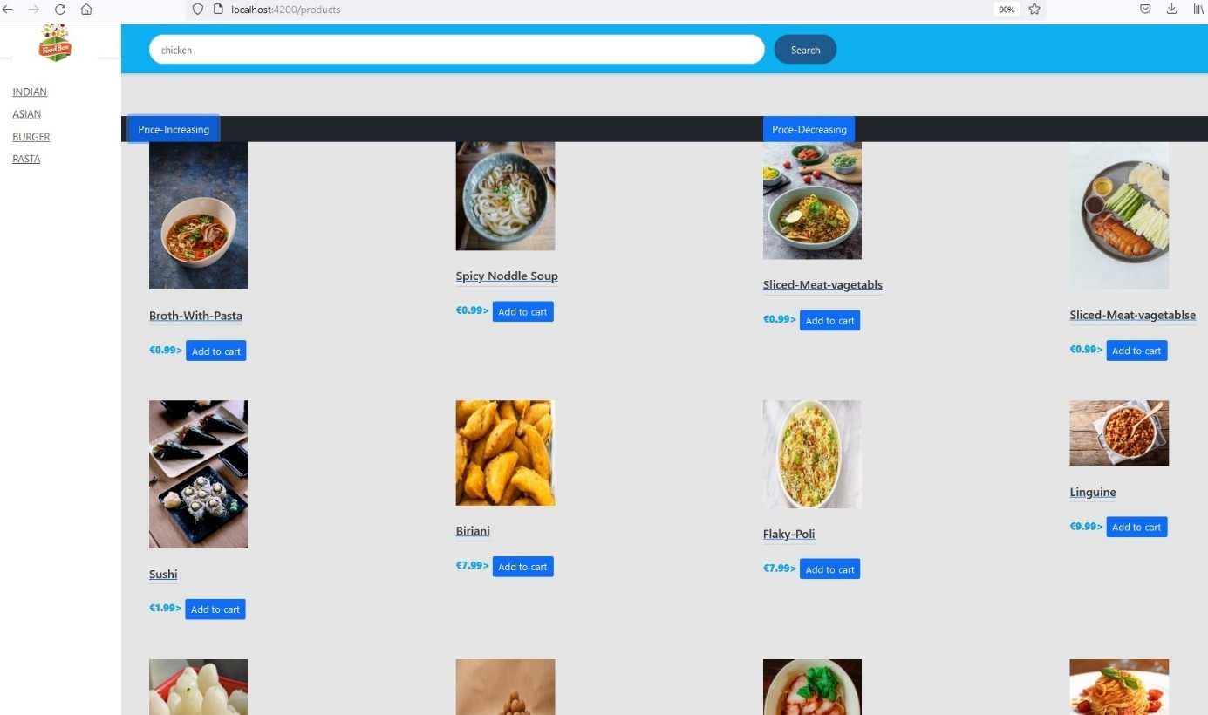

Figure 6:Sorting in price ascending order

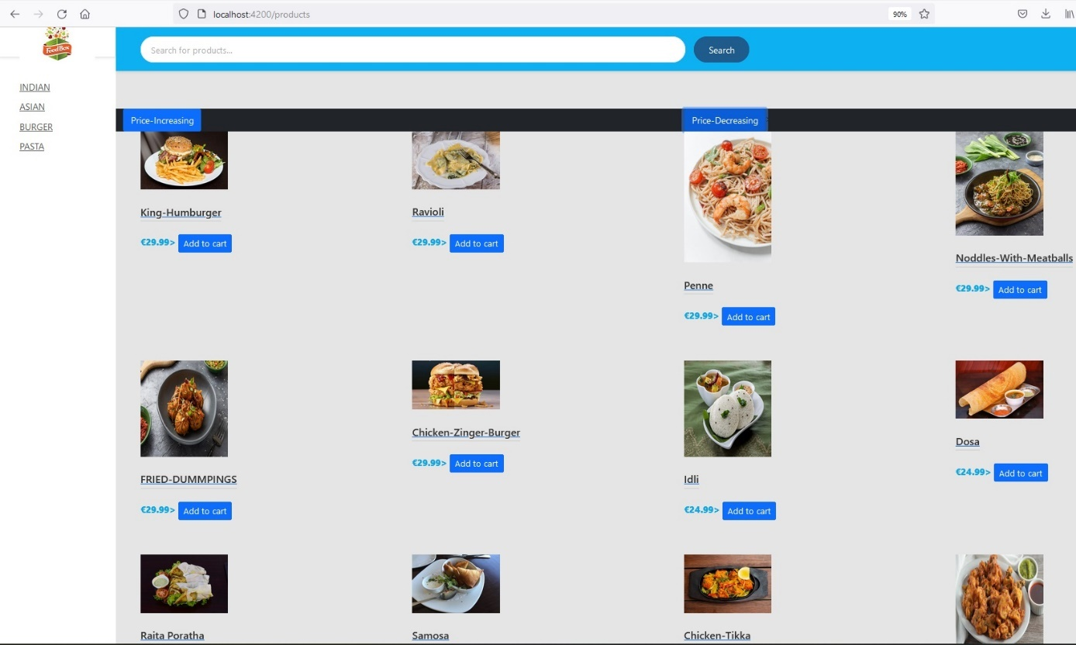

Figure 7:Sorting in price descending order

Product Detail-View: User can also get the details information of an item clicking on the item picture or the item name -Figure 8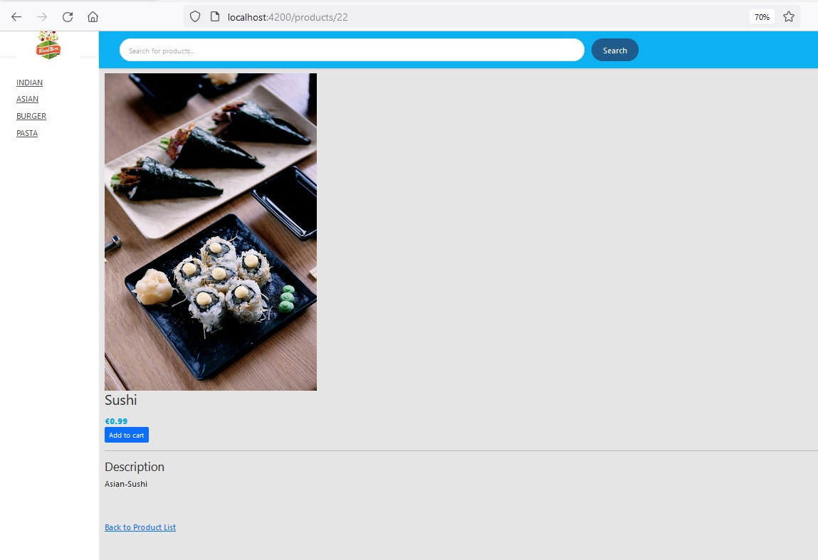

Figure 8:Detail-View of an item

User Login: Upon clicking on the Add to cart user will be taken to user login page. As an Exiting user one can login to the portal or as a new visitor can click on the Signup button to register in the system. Figure 9 shows the login-page.

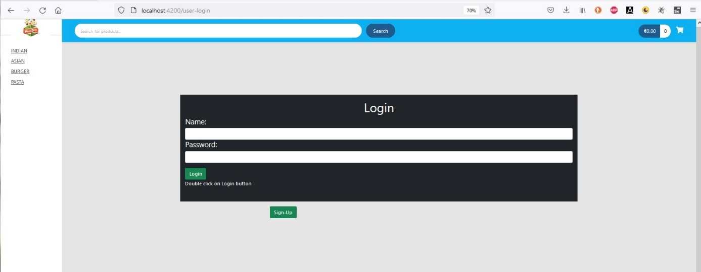

Figure 9: Figure of the user Login page

After clicking on the sign-up button, new visitor will be forwarded to sign-up page to fill up the necessary information [figure-10]

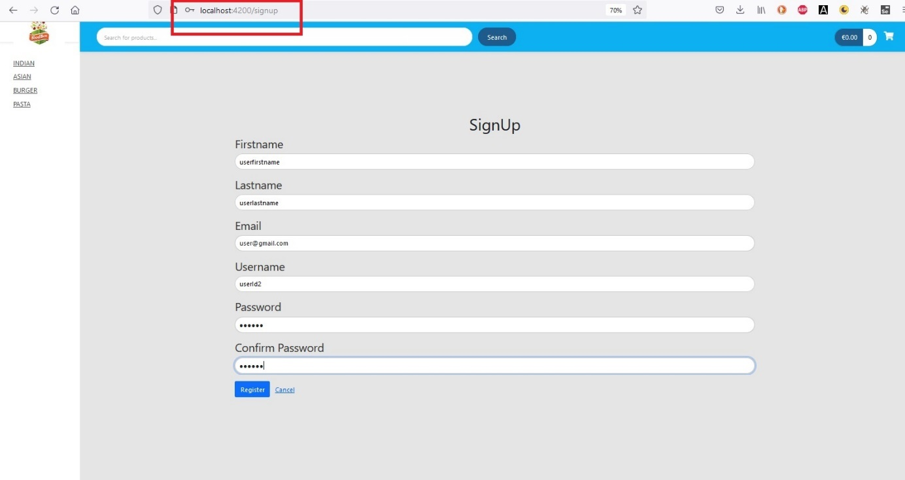

Figure 10:New User Registration

After the completion of a successful registration user will be return to user-login page to login freshly, which can be seen in figure 11.

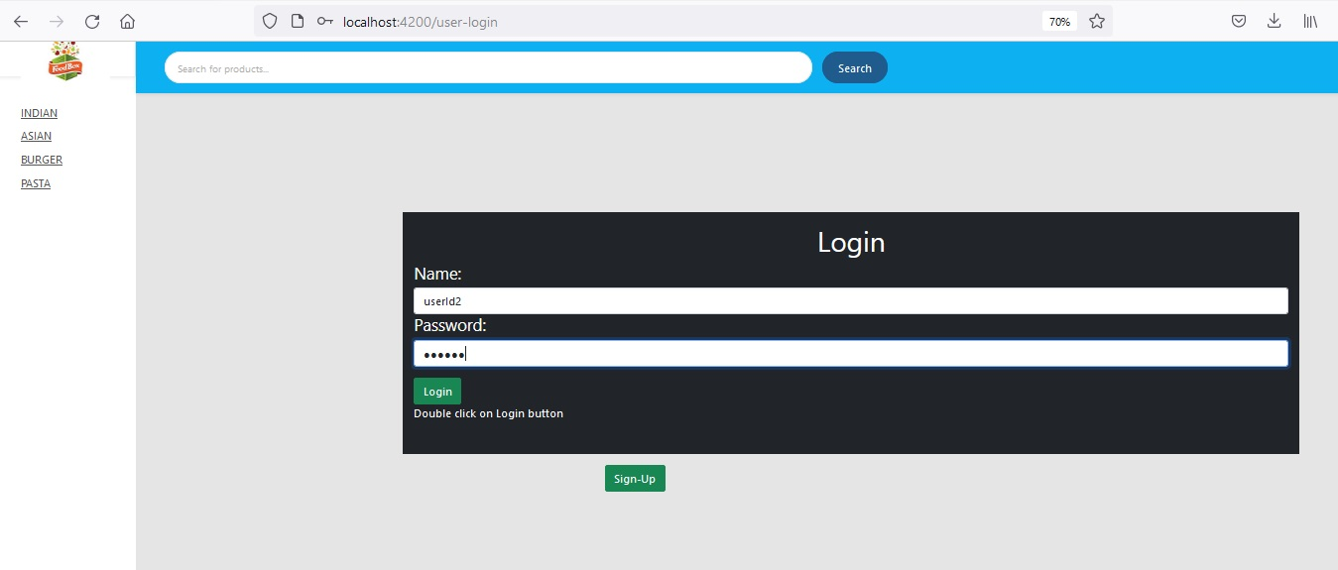

Figure 11:User Login

After login in the portal now user can see the logout button as shown in figure 12.

ss

Add product to cart: Now user can add product into the cart and figure 13 demonstrate the added quantity of the total item in the cart.

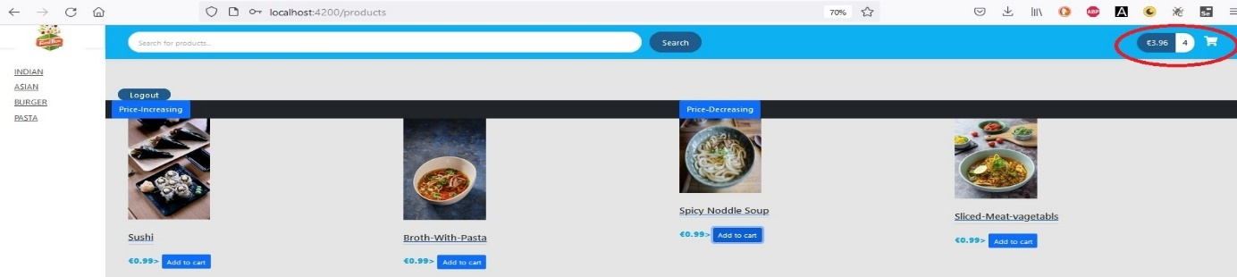

Figure 13:Items added to cart

Cart Detail view: Figure 14 shows that- Upon clicking on the cart button user can see the detail view of the cart and add increase or decrease the quantity of an item or can totally remove from the cart.

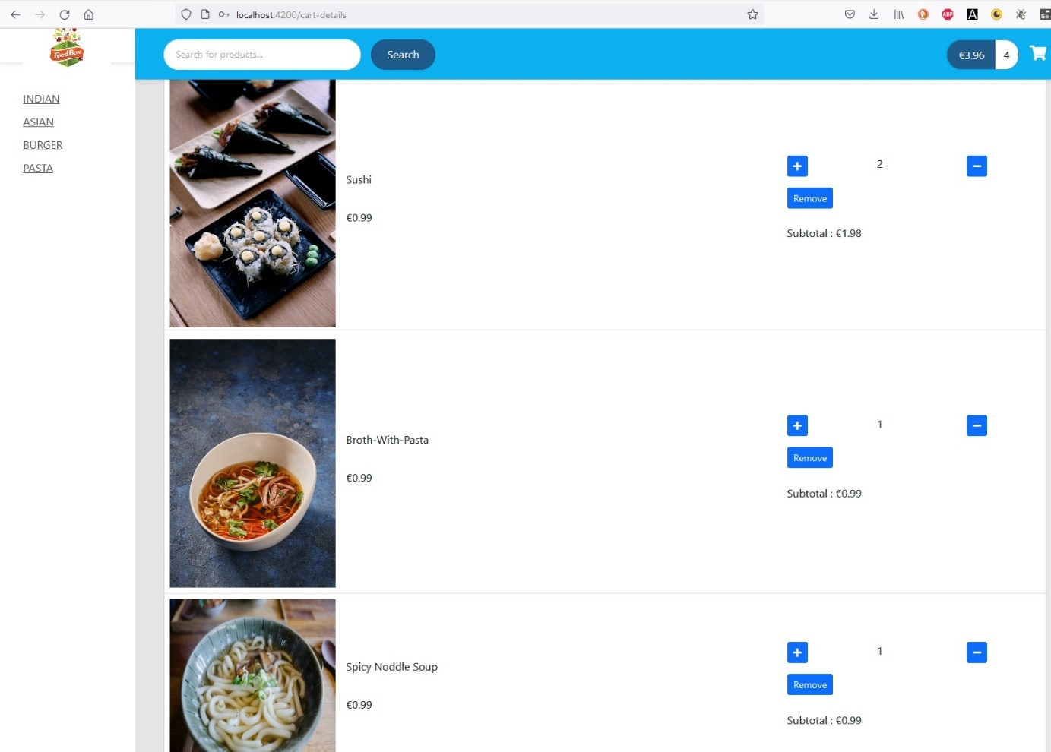

Figure 14: Detail View of the Cart

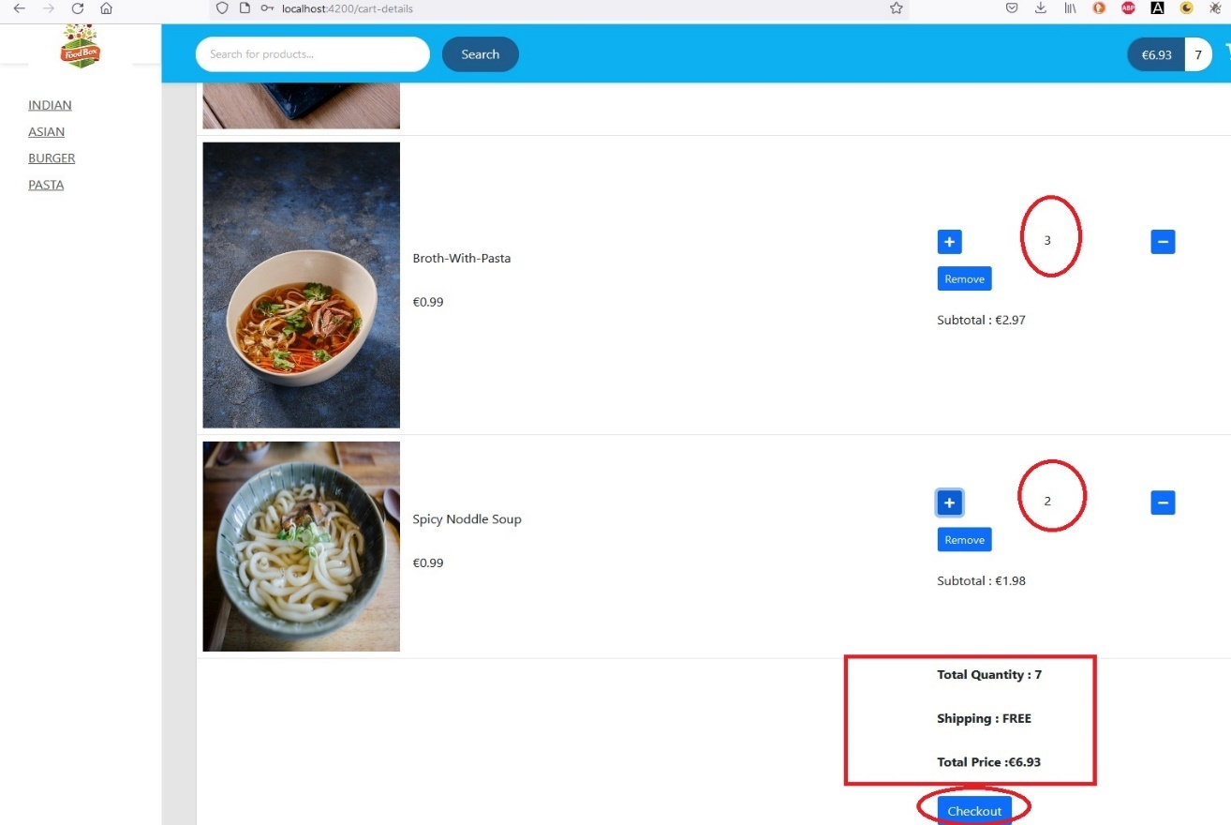

Figure 15:Incresed item quantity and display of the total quantity and price

In the above Figure 15 shows that user can increase an items quantity inside the cart and get the information about the total quantity and total price. The item name and the unit price of the item and can also be seen along with the item picture.

Checkout: User can checkout upon clicking on the checkout button on the detail cart view. Upon clicking on the checkout user will be taken to the purchase page[figure-17]. Figures 17,18 and 19 show the information of the user, the shipping and billing address, credit card option and Review of the order.

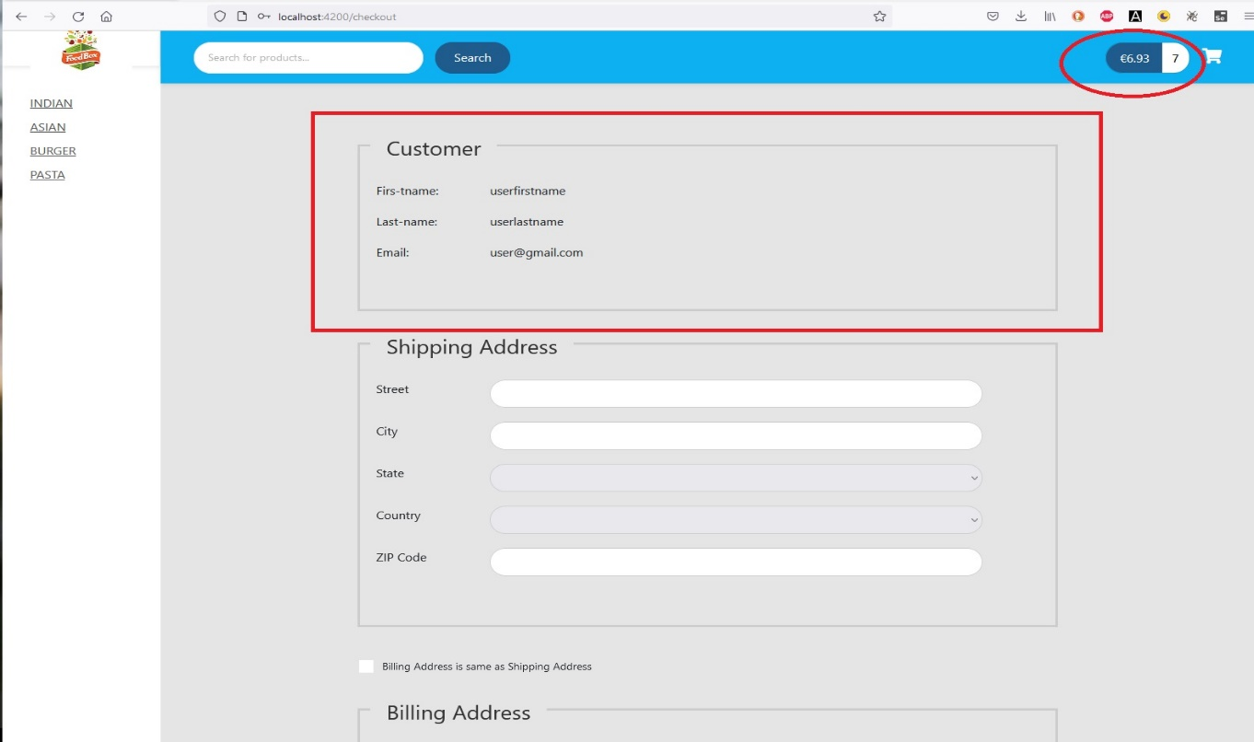

Figure 16: Check-out page

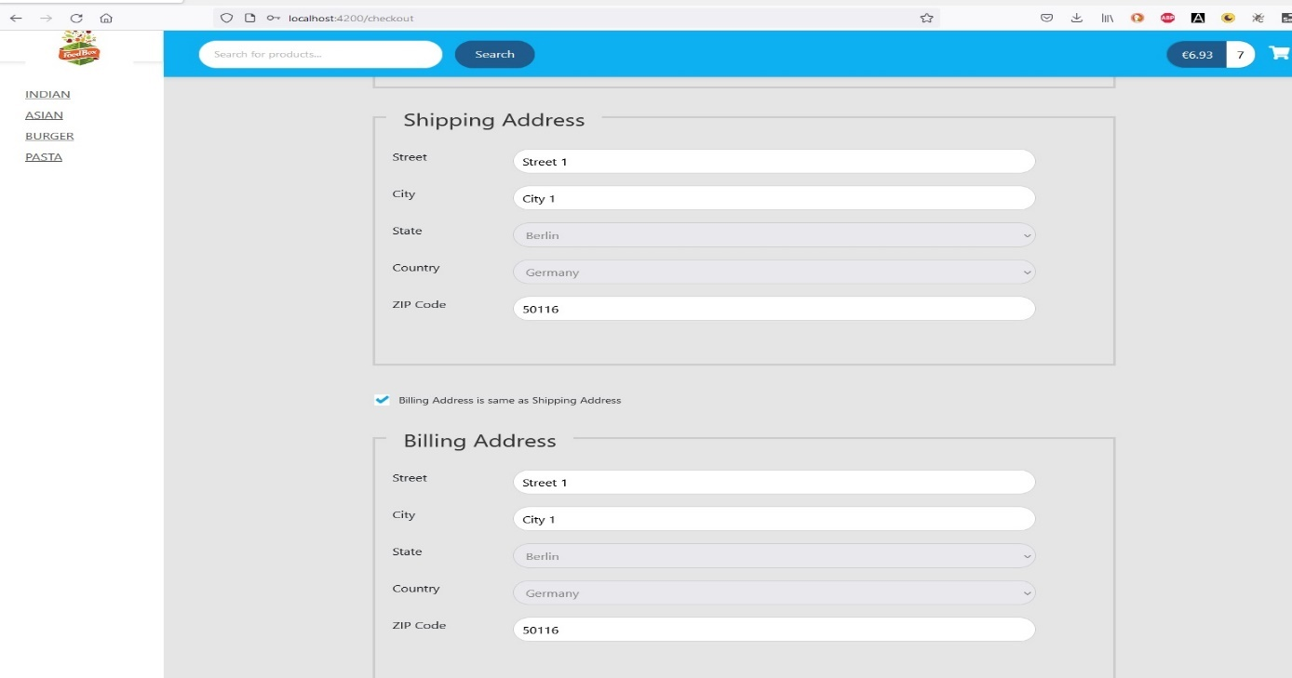

Figure 17: Shipping and Billing address in checkout page

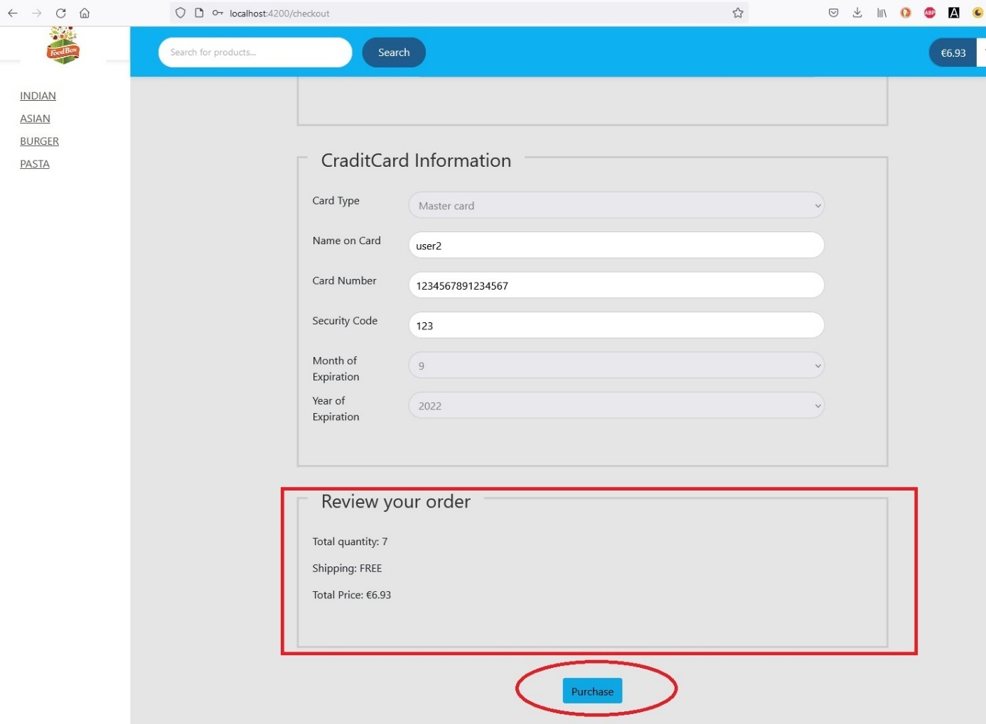

Figure 18: Credit card option and Review order

Upon filling all the required information and clicking upon on the purchase button an alert with the purchase id will be displayed to the user and return back to products page.

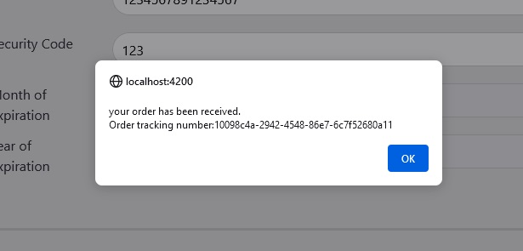

Figure 19:Alert upon successful purchase with the order tracking number

Upon clicking on the logout button user will be logged out and will be alerted and return back to login page as shown in figure 20 ,21and 22.

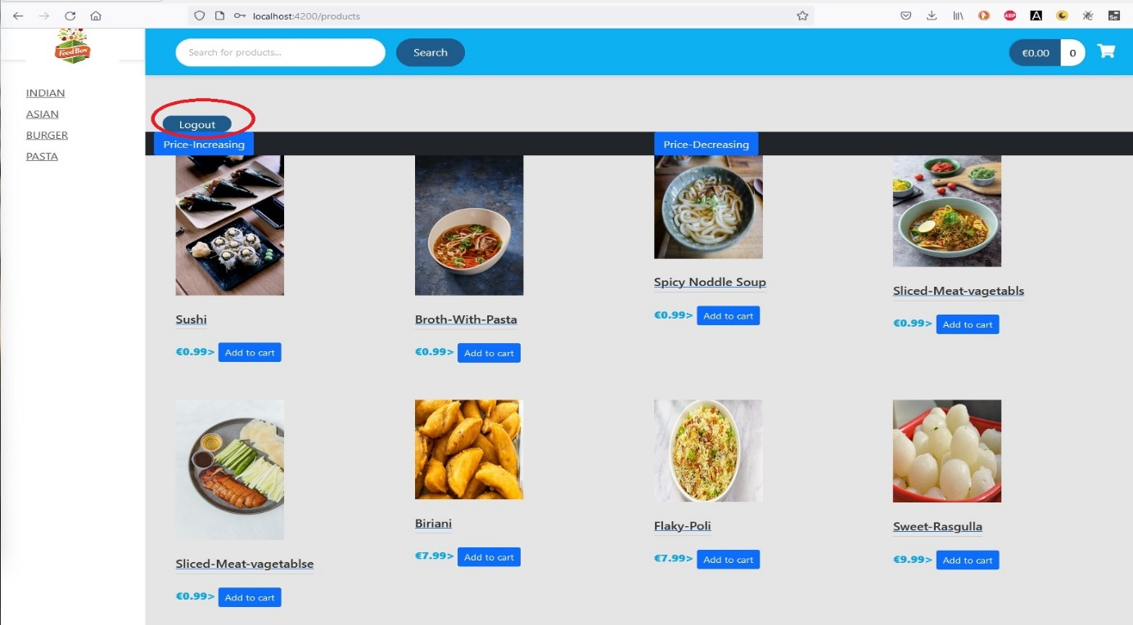

Figure 20:User Logout

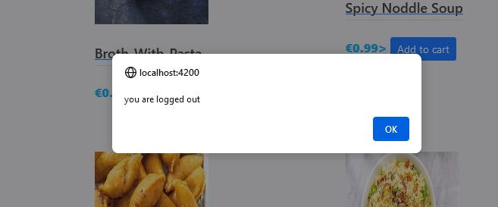

Figure 21: Alert Message upon successful Logout

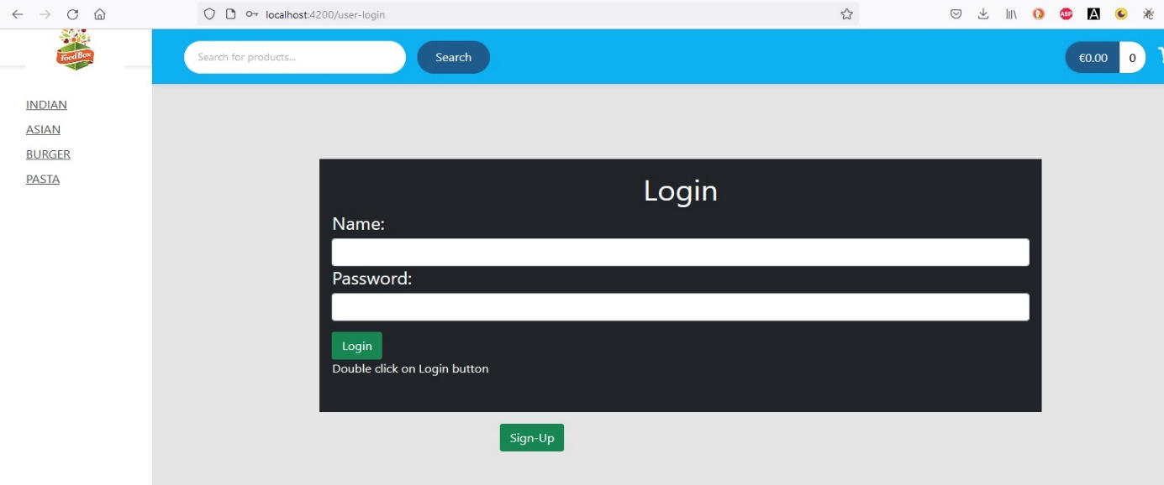

Figure 22:User-login page

# **Admin Portal**

Admin can use the Admin-Login button to visit the admin login page. Figure 23 shows the Admin-Login button.

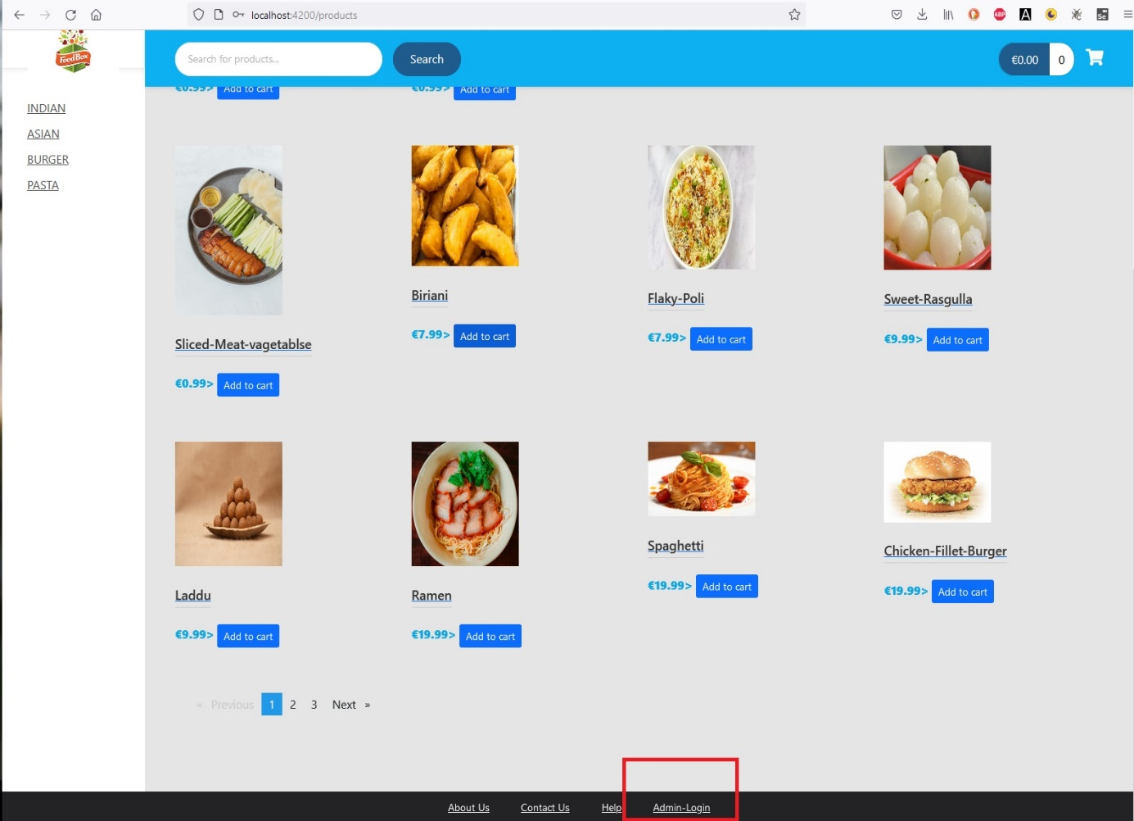

Figure 23:Admin-Login button

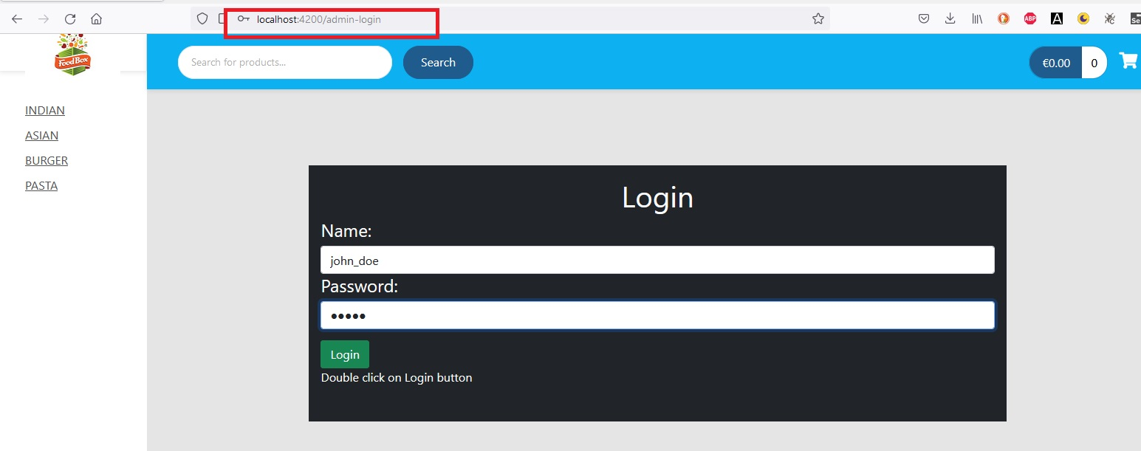

Figure 24:Admin-Login page

Upon successful login an Admin will be redirected to the dashboard page as shown in figure 24. Where admin can update and create items and also create category and also enable or disable an item.

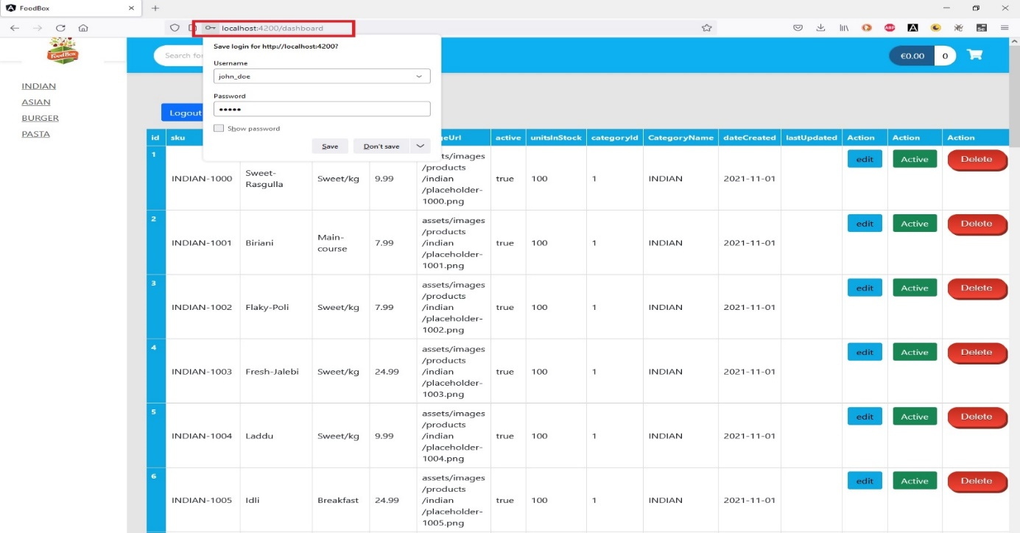

Figure 25:Dashboard

Enable or Disable an Item:

Admin can disable an item clicking on active button which represents that the item is active for user selection[figure-26]. After disabling the item this button will change to deactivate mode and red in color [figure-27]

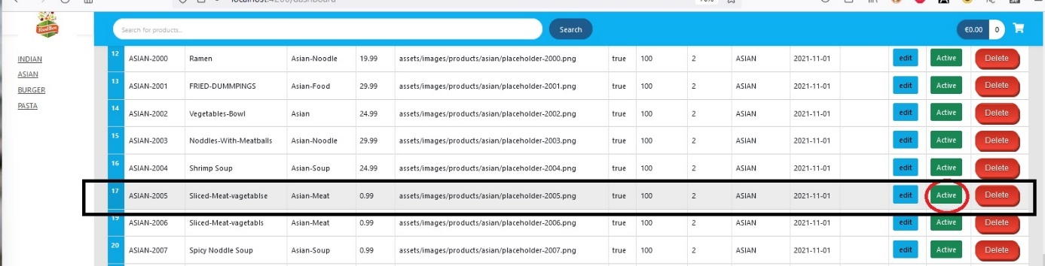

Figure 26:Disable an active product

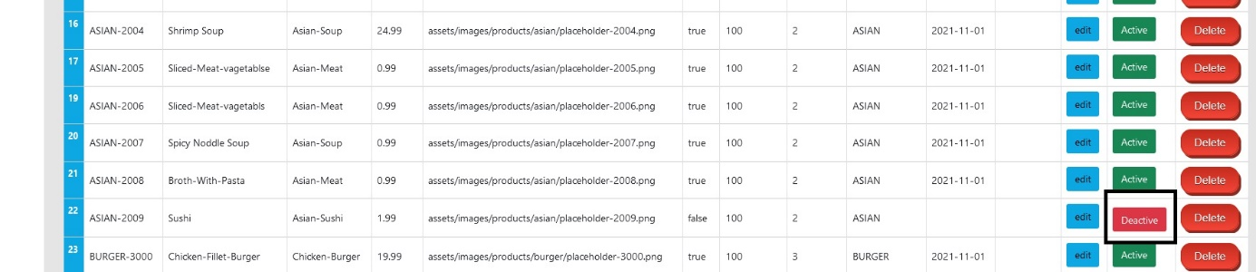

Figure 27:Disabled Product

After being deactivated an item will be blurred and option “Add to cart “will be changed to “Out of Stock”. User can also not see the detail view of the product upon clicking on the blurred picture of the item, which can be seen in figure 28.

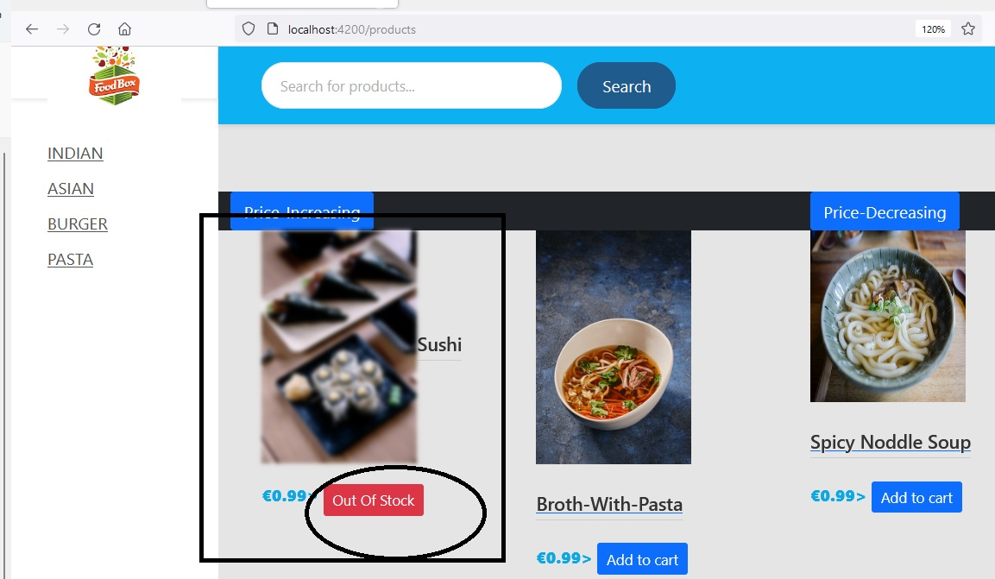

Figure 28:Disabled product

This product with ID 22 can be updated with the edit button. Figure 29 and 30 show the new update of this product item.

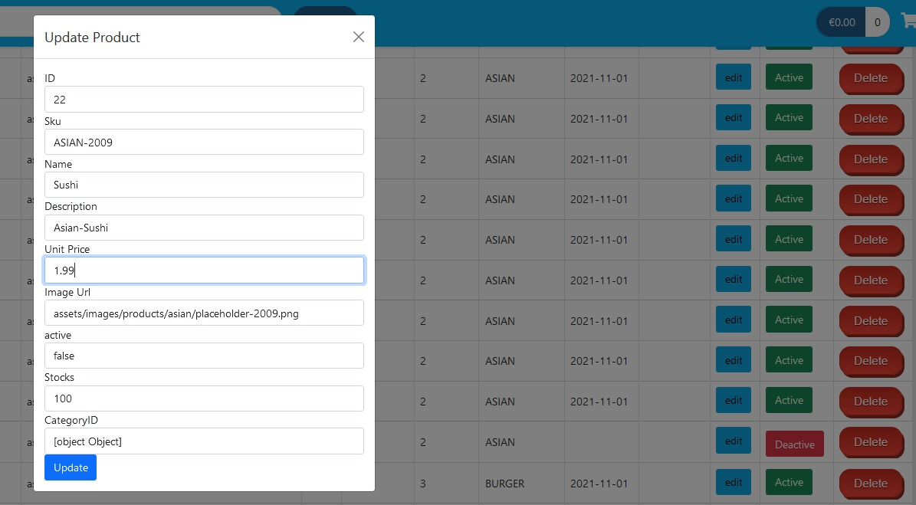

Figure 29:Updating a product through the edit button

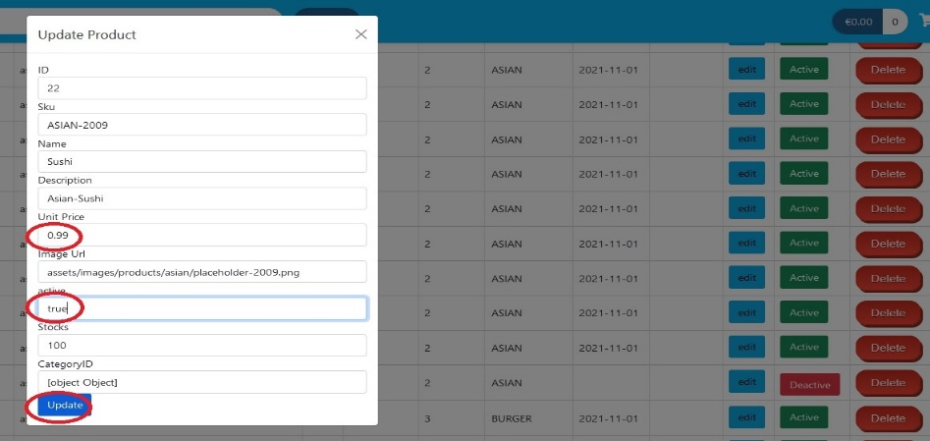

Figure 30:Changed Value to update an item

Figure 31 represents the updated product price and enabled condition of the product .

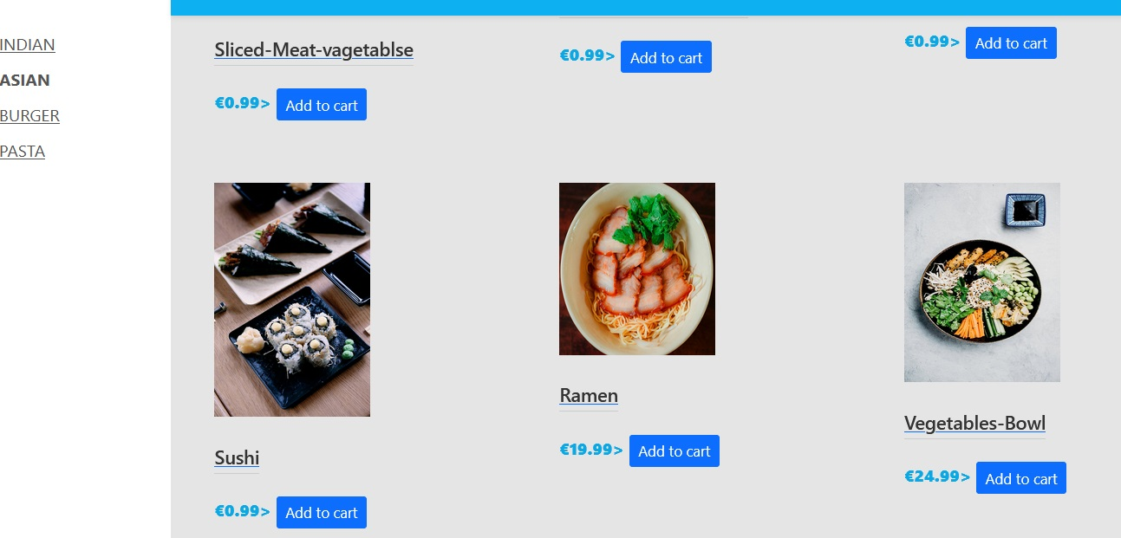

Figure 31:The Updated product price and enabled condition of the product .

**Delete an item**: an item can be deleted upon clicking on the delete button, which can be seen from figure 32 and 33.In figure 32 last item ID is 33 , when in figure 33 last ID is 32 and item with id 33 is deleted.

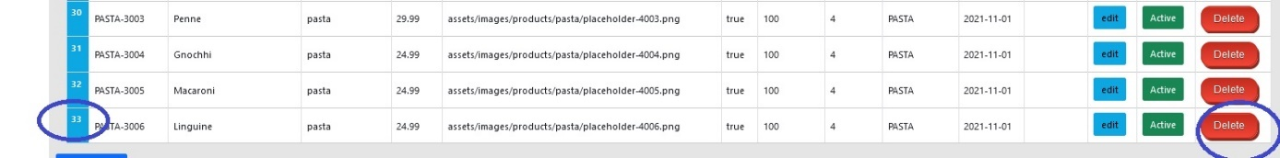

Figure 32:Delete an item with the delete button

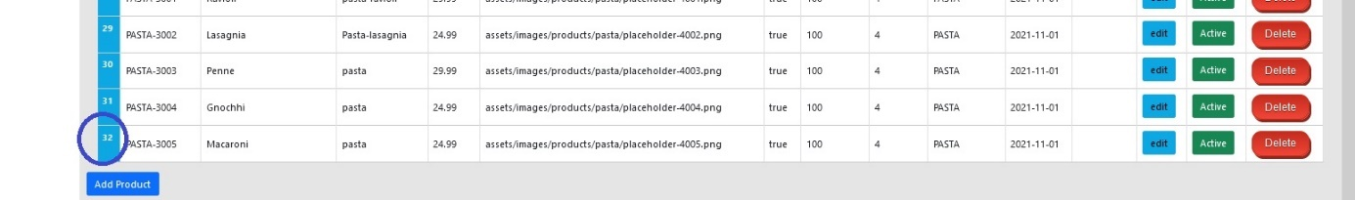

Figure 33:ID 33 was deleted successfully

Add an new item: Admin can add an new item with the Add product button as in figure 34

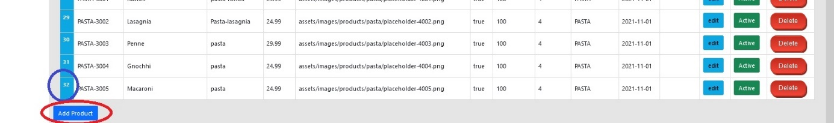

Figure 34:Add new Product

Upon clicking on the button “Add product” an new window will appear to fill in all the information of the new product [figure-35]. Click on the “Add” button will create the new product which can be seen in figure 35 with the ID 34 and in figure 37 also displayed for the user.

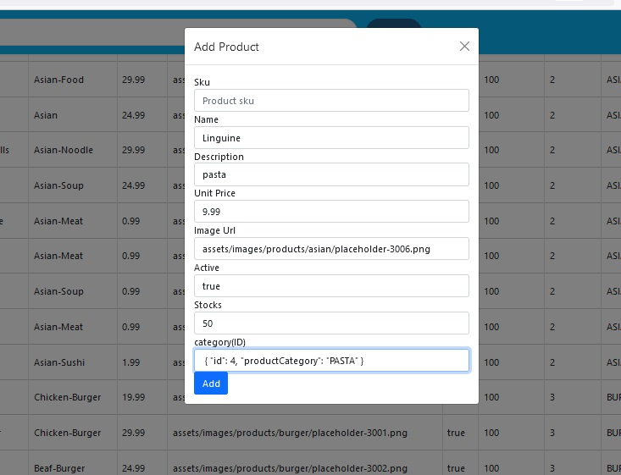

Figure 35:Information for adding a new product



Figure 36:Added new product

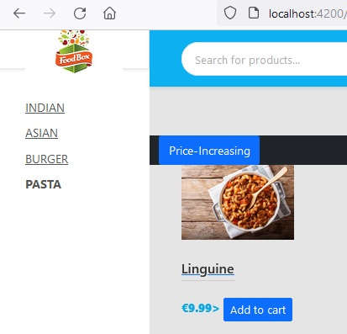

Figure 37:Added product displayed for users

Similarly new Category can be created with the button “add Category” as in figure 38

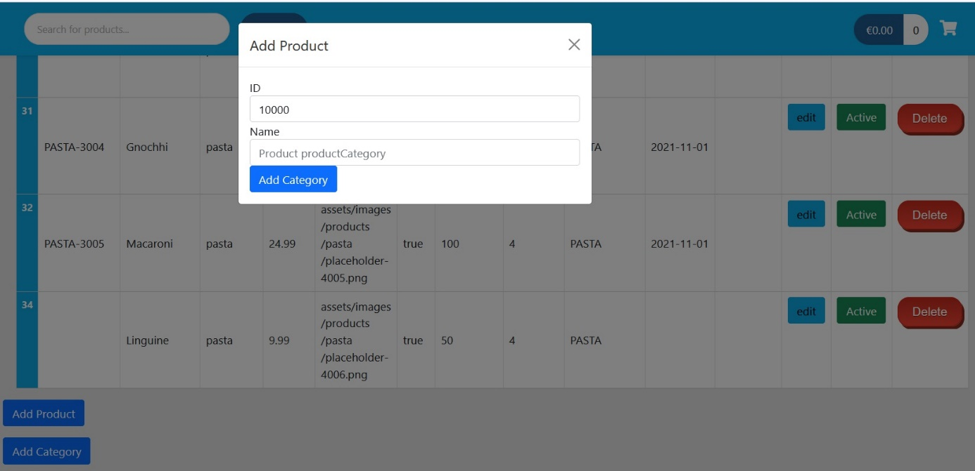

Testing:

Backend Pojos was tested with junit and Mockito framework. Result is as follow:

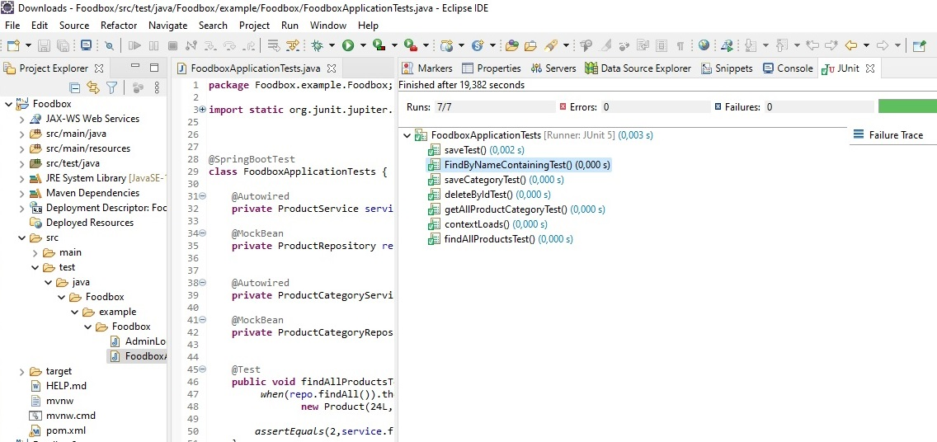

Figure 38:TDD BackendTest-1

Tests were also performed for the User and Admin login and output can be seen in the figure below:

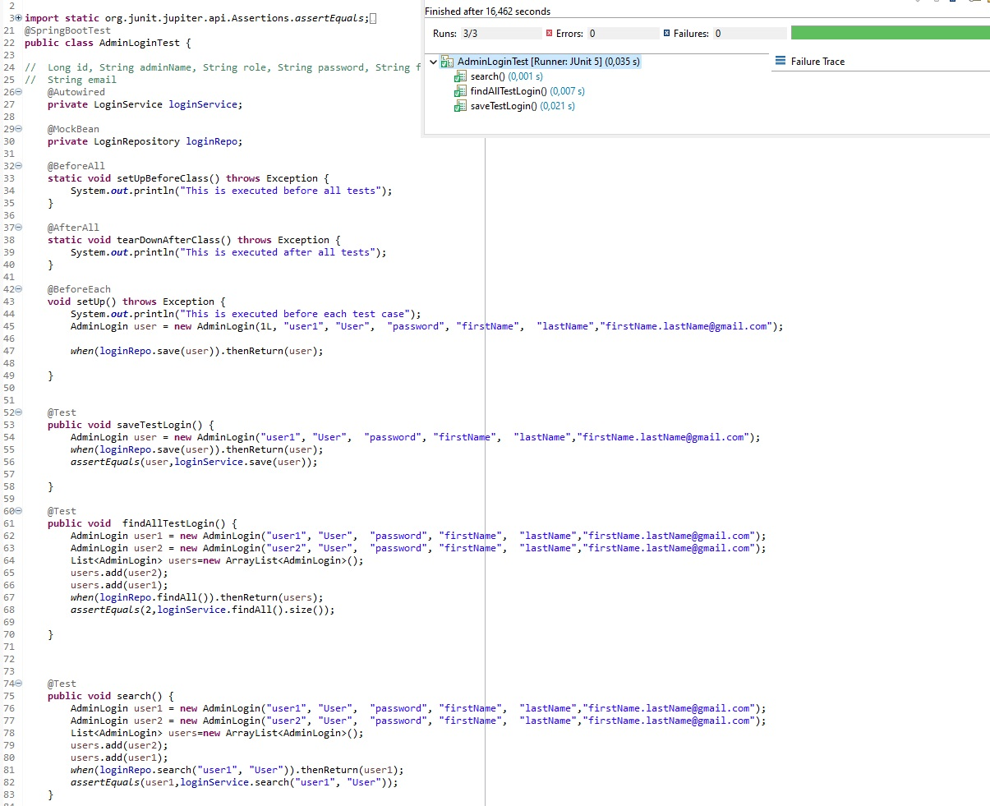

Figure 39:TDD Backendtest-2

Frontend Testing was done with Jenkins and java project. The link for the project is at the Github-repository Link: https://github.com/sudip34/FoodBoxTestWithJenkins.git.

The results of the tests can be summarized with following figures of the Jenkins job

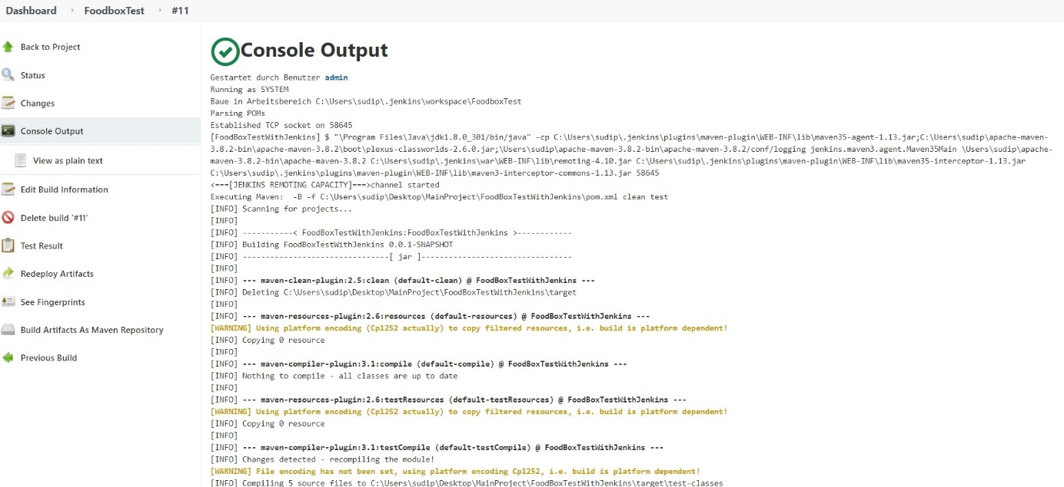

Figure 40: Frontend Test with Jenkins

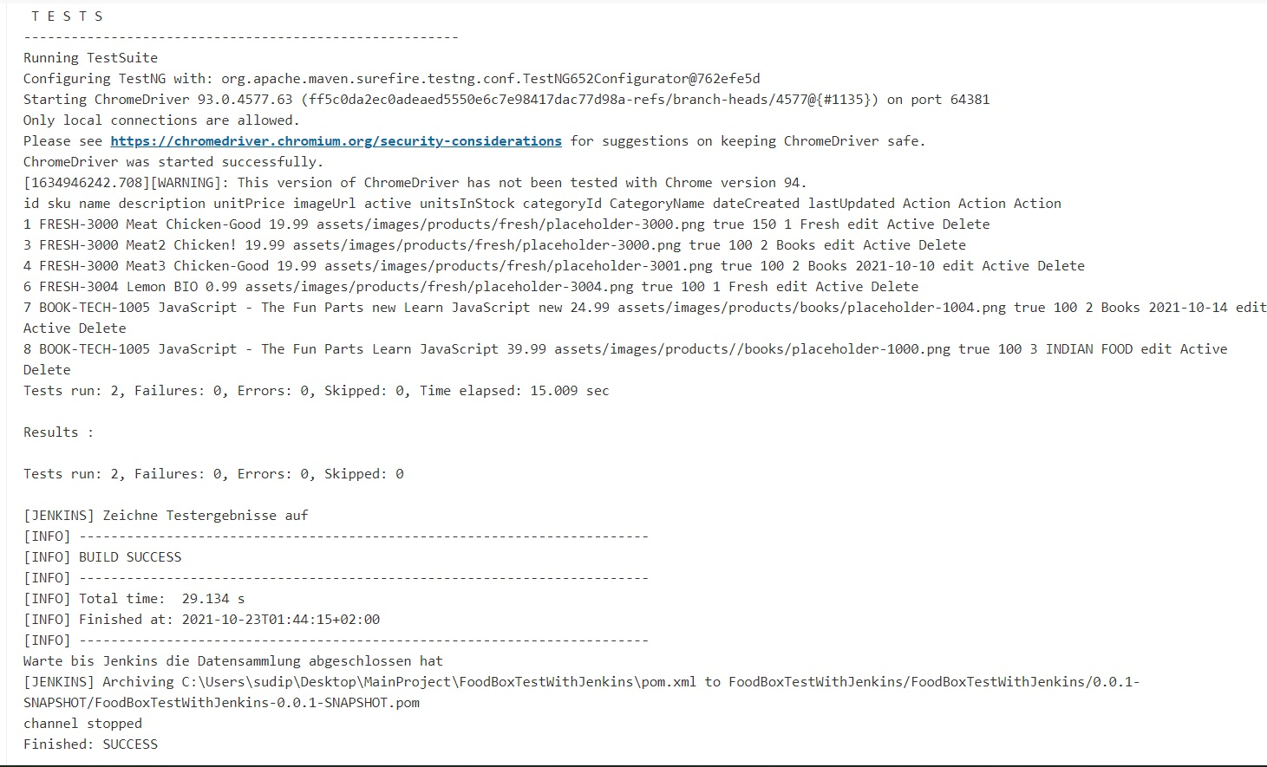

Figure 41: Frontend Test with Jenkins

## Deployment

For the Deployment 3 Ec2 -instances has been created named Jenkins_server, Docker_Host and Ansible server as in Figure shown in figure 42 and 43. In the Jenkins_server Jenkins was installed to automate build upon any change in GitHub Repository. Java Openjdk-11 and Git were also installed in the Jenkins server.

And One RDS instance was created for the MySQL server.

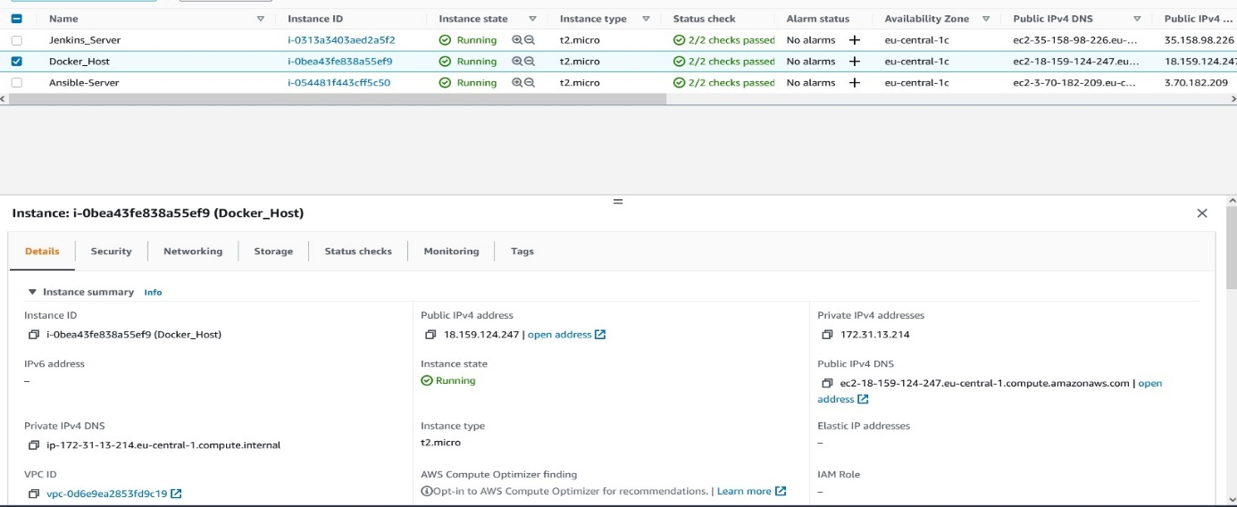

Figure 42: Docker_Host Details

In the Docker_Host server docker images will be build and run in docker container.

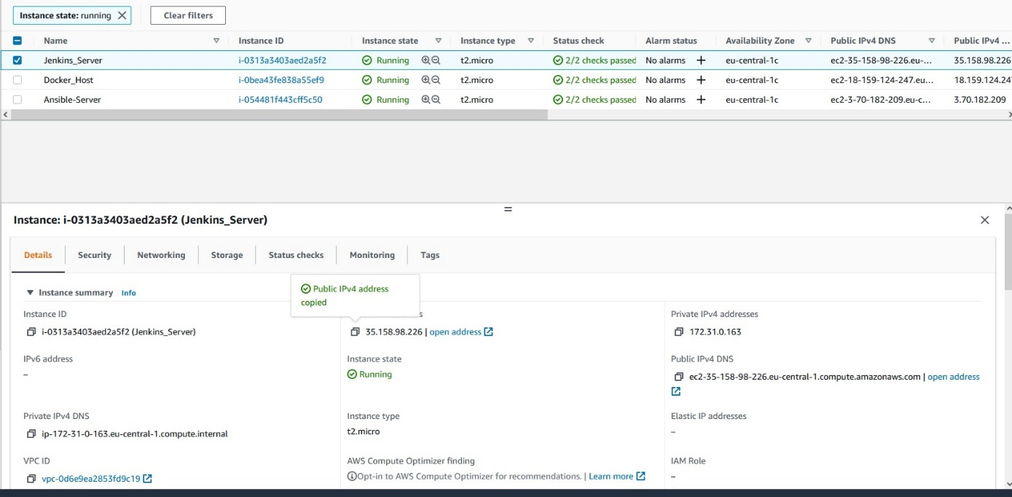

Figure 43:Jenkins_server Details

First one new Item/Job with the name Foodbox_Deploy_On-Docker_2 was created as freestyle project configured as in figure 44,45 and 46, where Jenkins were configured to listen any changes in GitHub Repository and automate the clone and build.

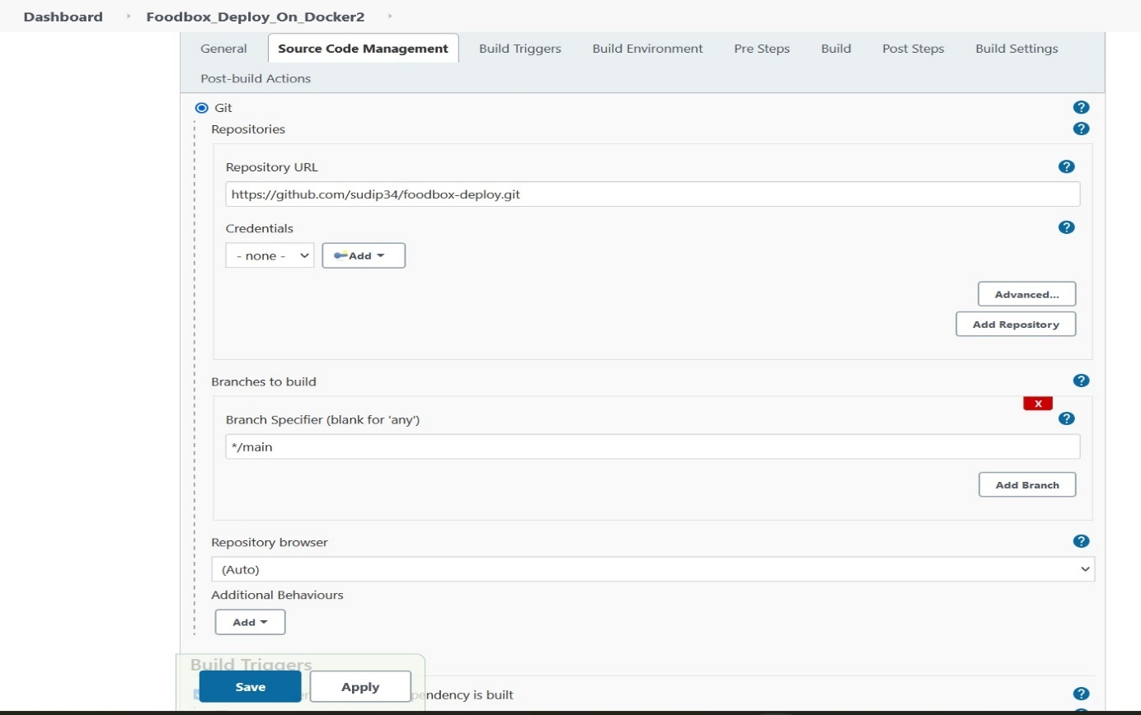

Figure 44:Jenkins configuration for git clone from the GitHub Repo.

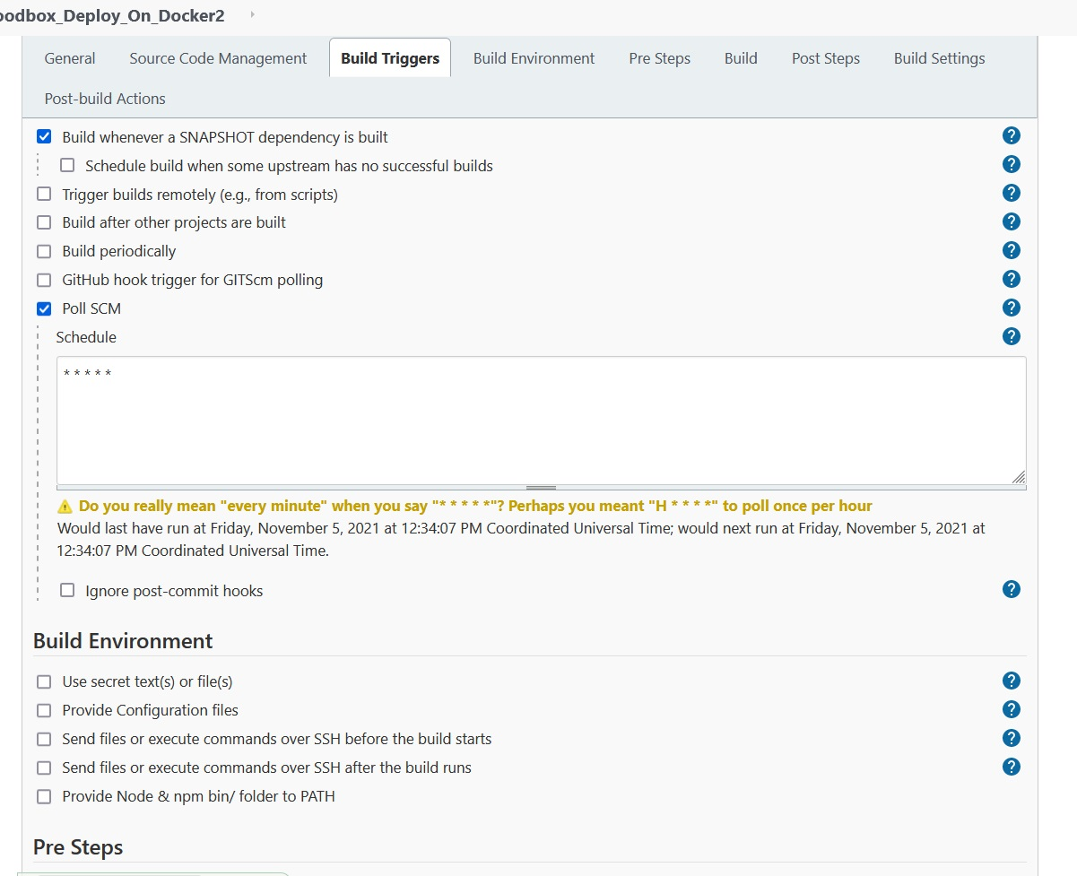

Figure 45:Configration- Poll SCM for listing any changes in Github Repo

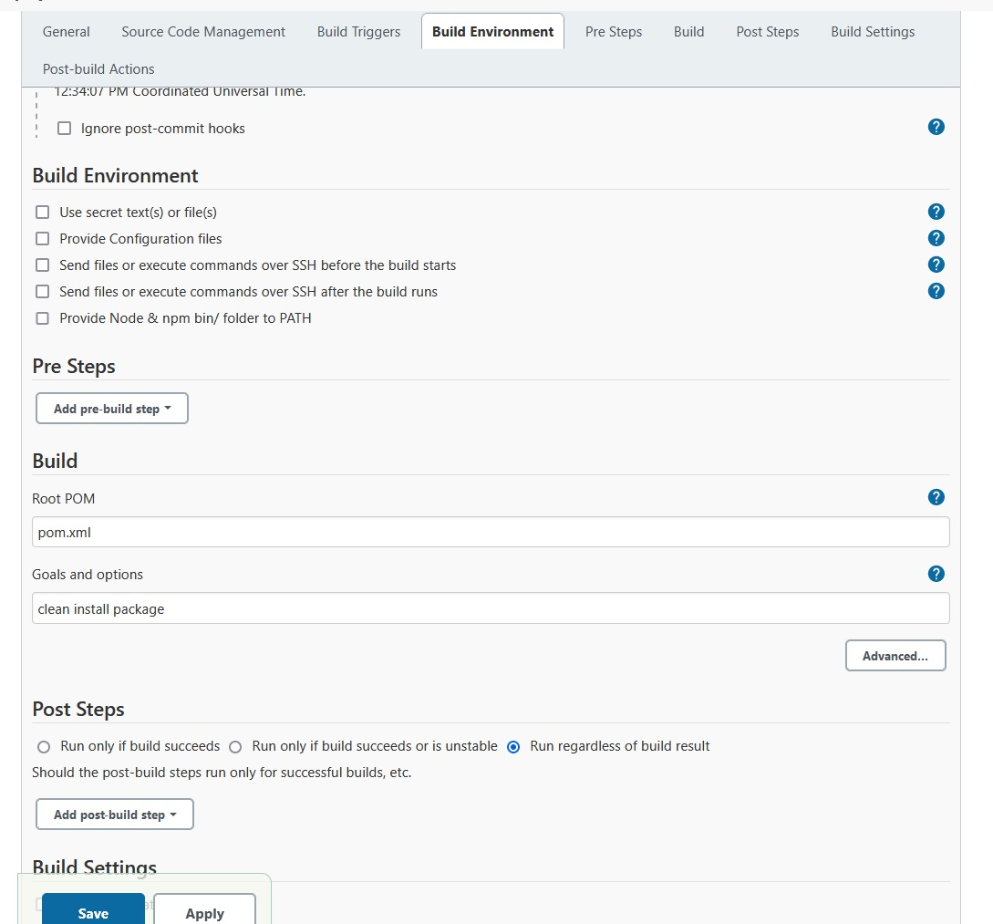

Figure 46: Configuration for Maven build

In Ansible_Server ansible was installed to automate the creation of a new docker image in ansible server and push it to docker hub and to delete the image and then the stop and delete the old container and pull the new image form the Docker Hub and at the end perform the Docker run to Run in the container.All this were done with Ansible playbook.

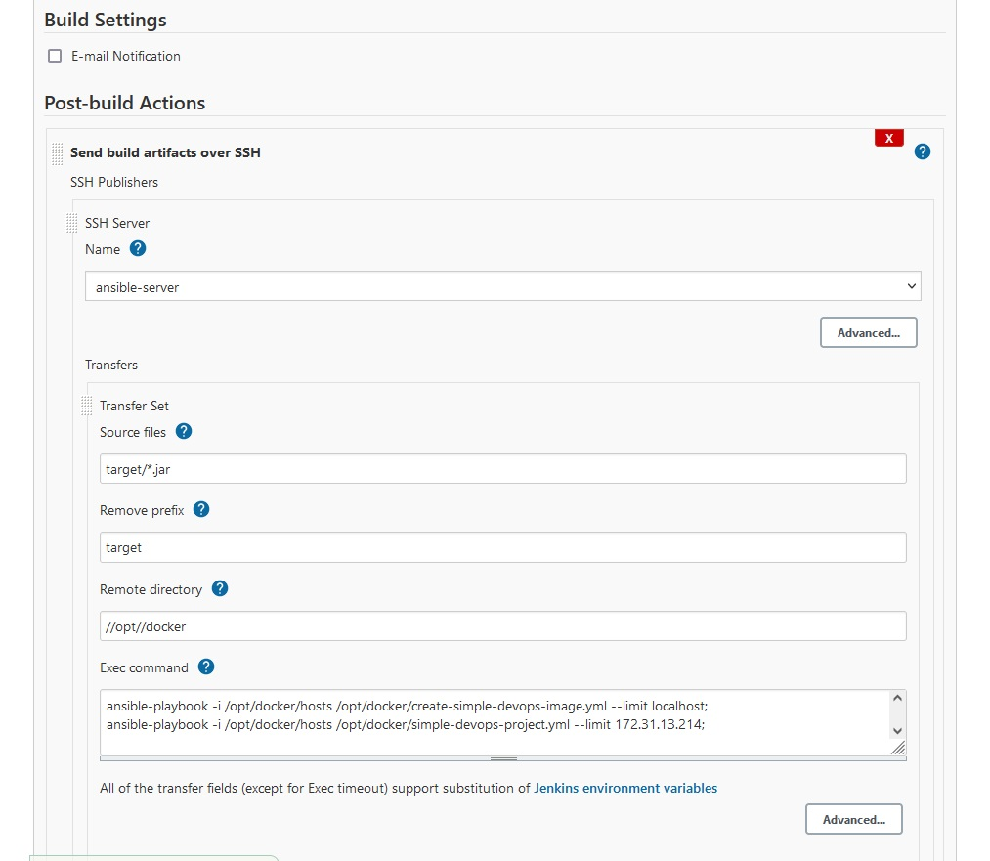

Figure 47:Ansible Playbook to create new Docker Image and push it to Docker hub and to create container out of it

Figure 48 and 49 show the successful build of this project.

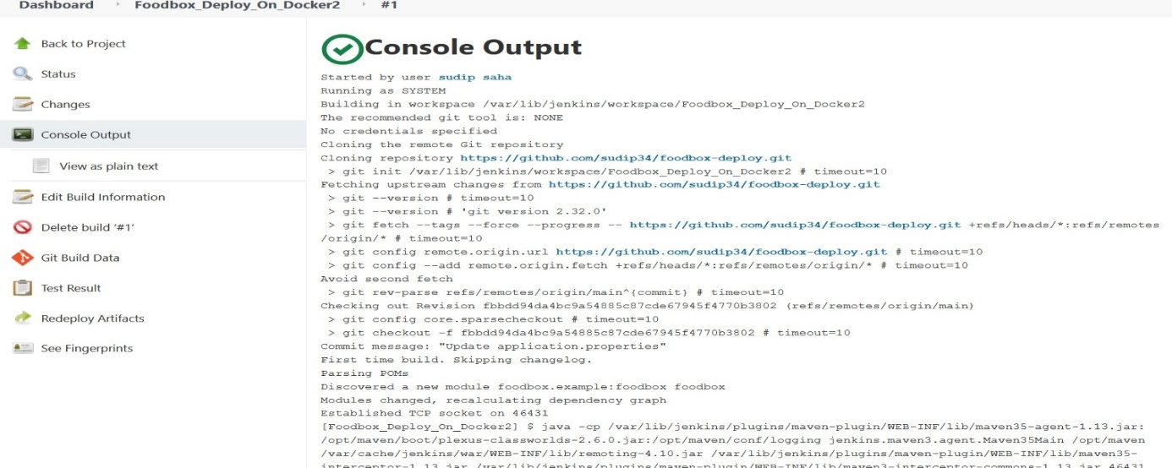

Figure 48:First successful build and Console Output

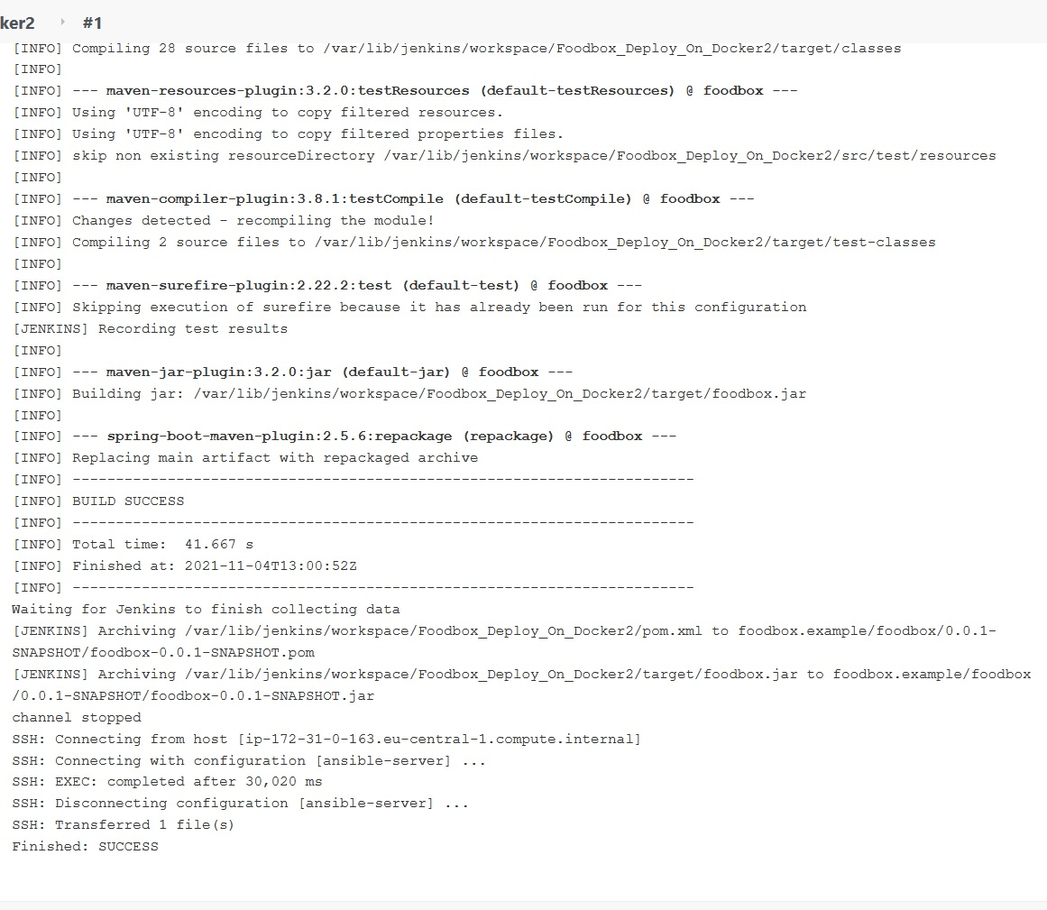

Figure 49:First successfull build

Figure 50 shows the GitHub Repository for this project.

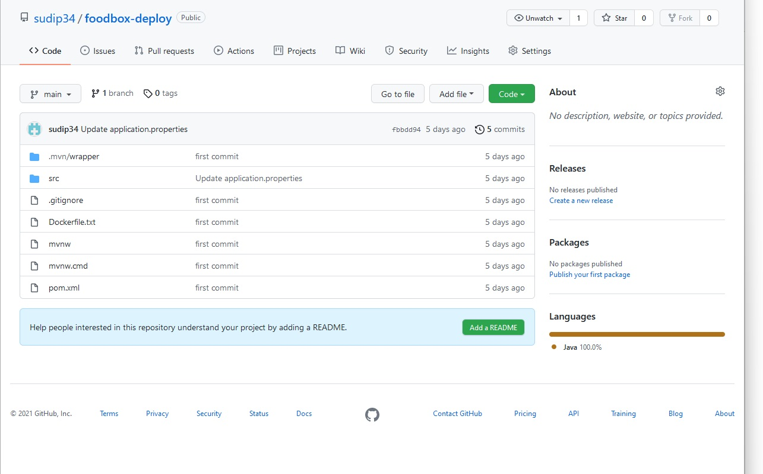

Figure 50:GitHub-Repository for the code to deploy

Figure 51 shows the change on the GitHub Repository.

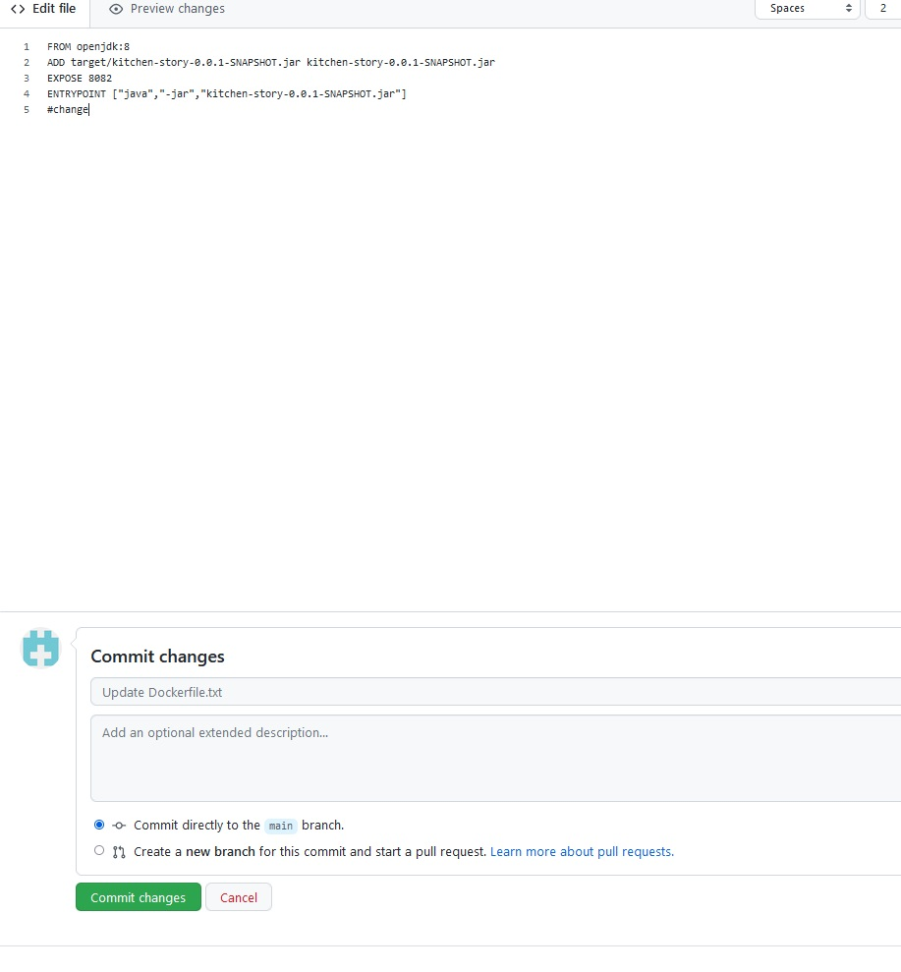

Figure 51:Changes in GitHub Repository

With the change in the GitHub Repository Jenkins will start to clone the new Repo and build it again as it can be seen in figure 52.

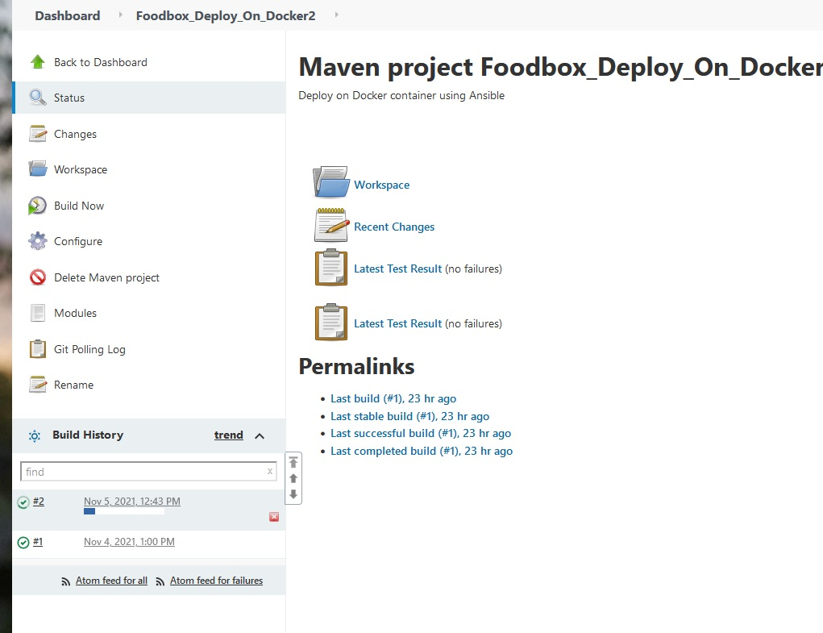

Figure 52:New automatic build has been started

Figure 53 shows the successful second build of this project

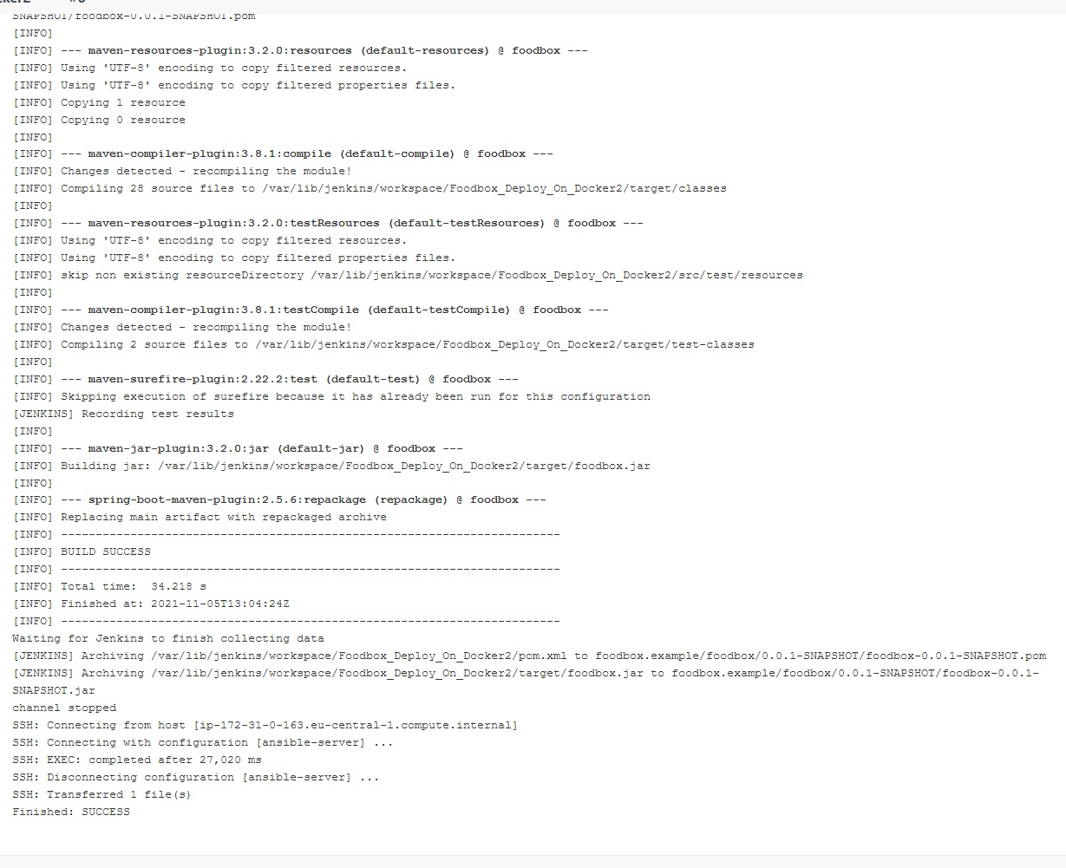

Figure 53:Second successful build

Figure 54 represents the new image pushed into the Docker Hub (33) after the first successful build.

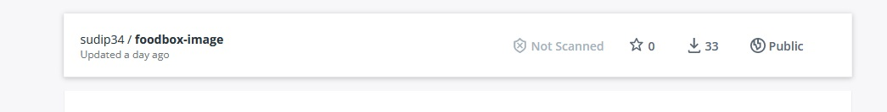

Figure 54:pusehd image on the Docker Hub after 1st build

Figure 55 represents the new image pushed into the Docker Hub (42) after the second successful build

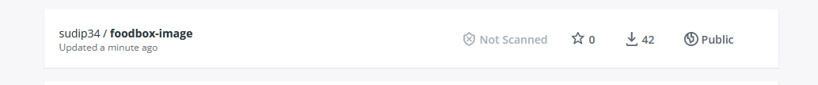

Figure 55:pusehd image on the Docker Hub after 2nd build

Now upon successful build docker container was created in the Docker_Host with Public_ip - 18.159.124.247.Figure shows that the Rest Endpoints one can get the responses.

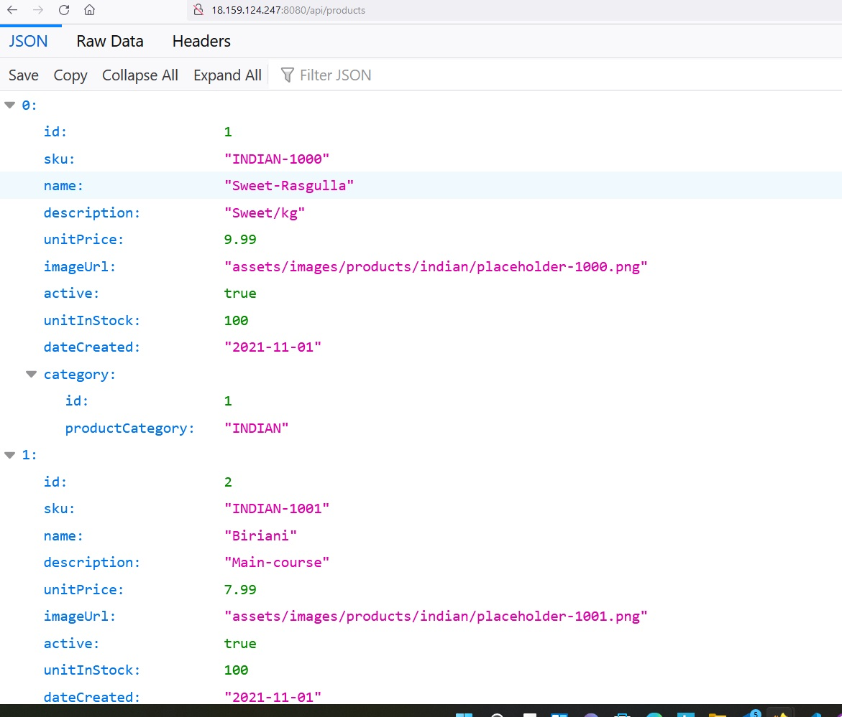

Figure 56:Output of the Docker Container under Docker_Host with Public_ip - 18.159.124.247

**Frontend Deployment**

Two AWS Ec2 instances were created as master Jenkins-server and slave https server, which can be seen in figure 57.A new pipeline has been created to perform the ci/cd with a Jenkinsfile.

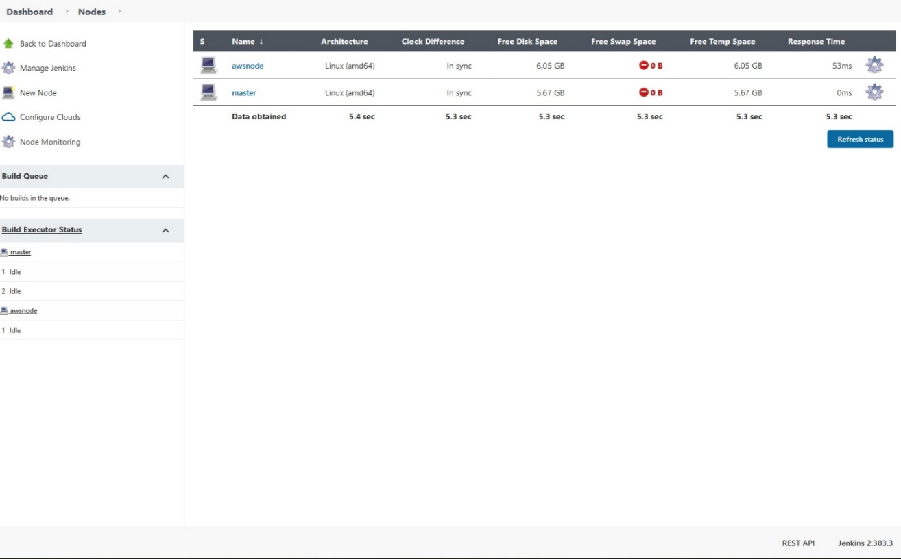

Figure 57:Master Jenkins server and Slave https server

Figure 58 and 59 show the configuration for creation of the CI/CD with jenkinsfile from the GitHub Repository.

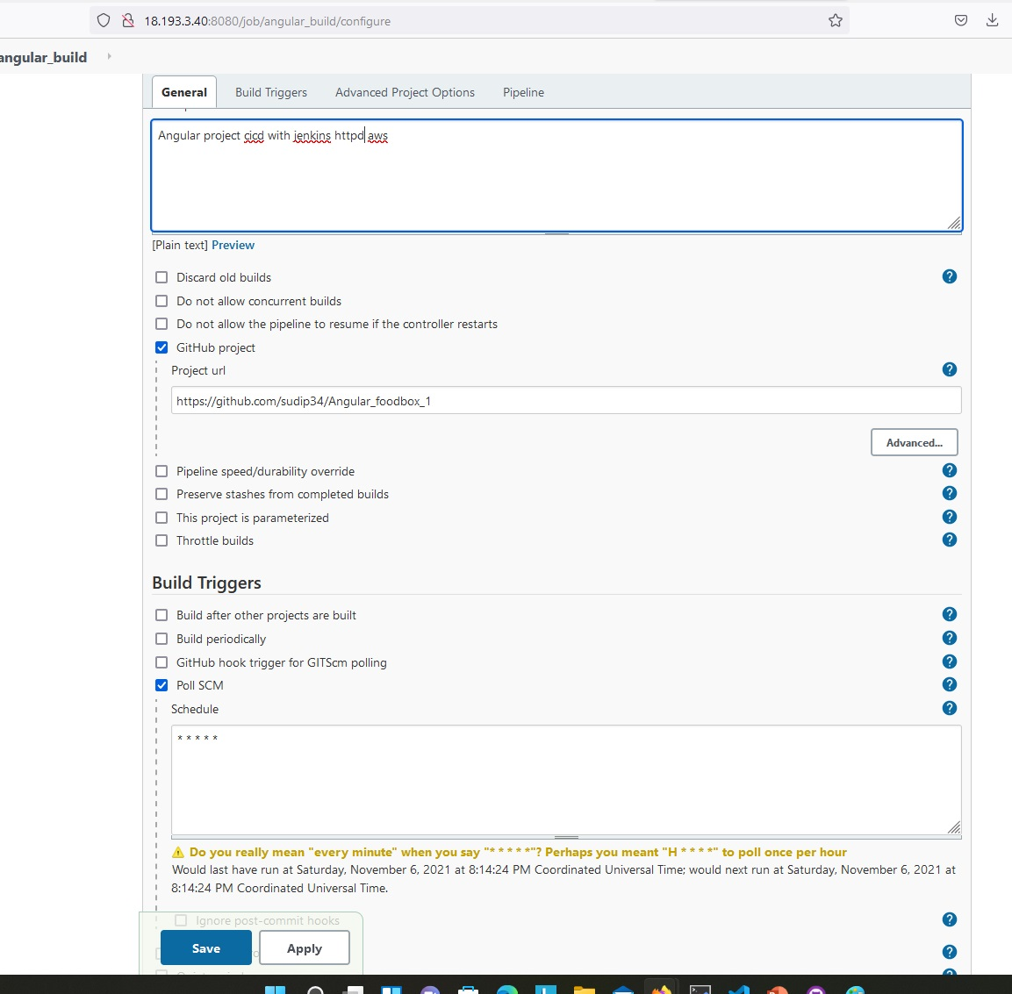

Figure 58:Jenkins configuration for CI/CD

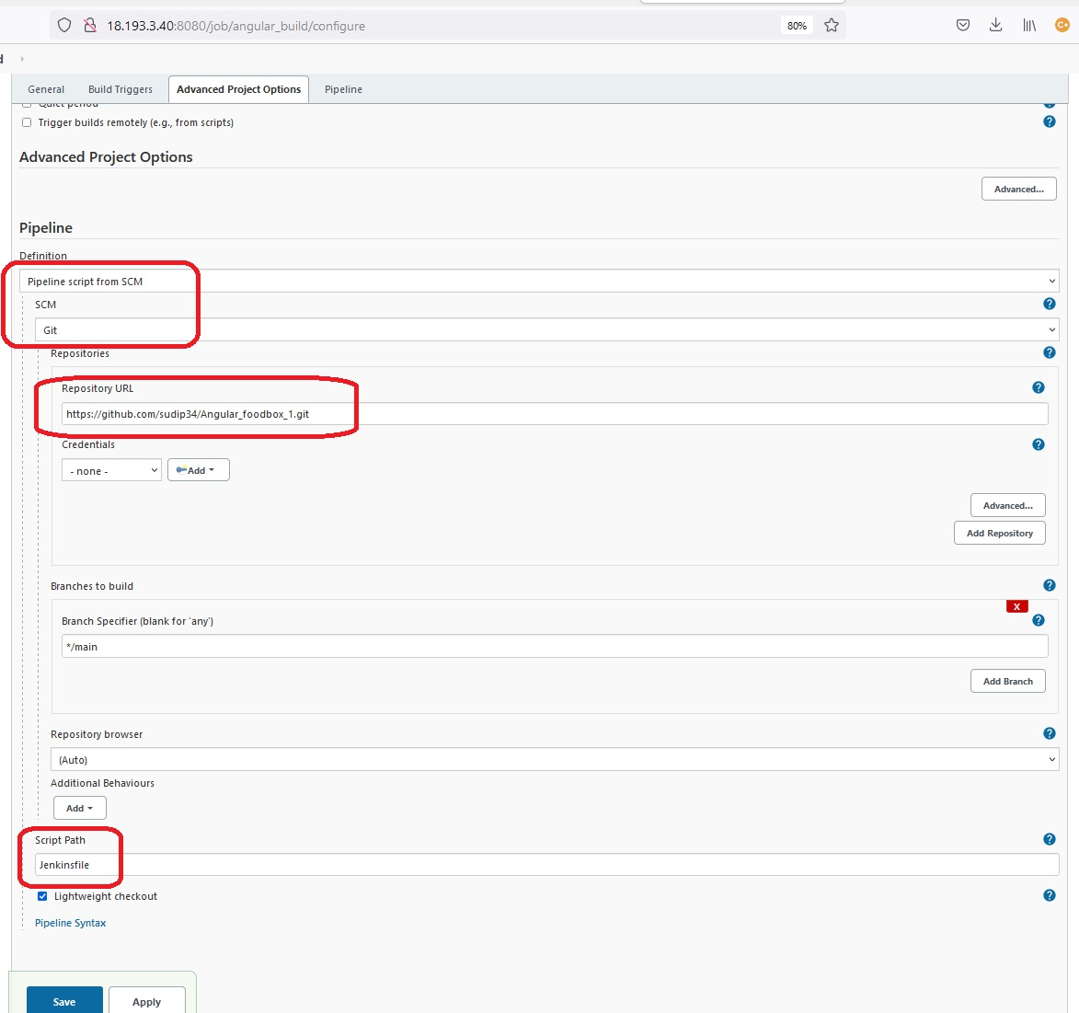

Figure 59:Jenkins Configuration with a Jenkinsfile to create a CI/CD

Figure 60 shows the first successful build of the angular project.

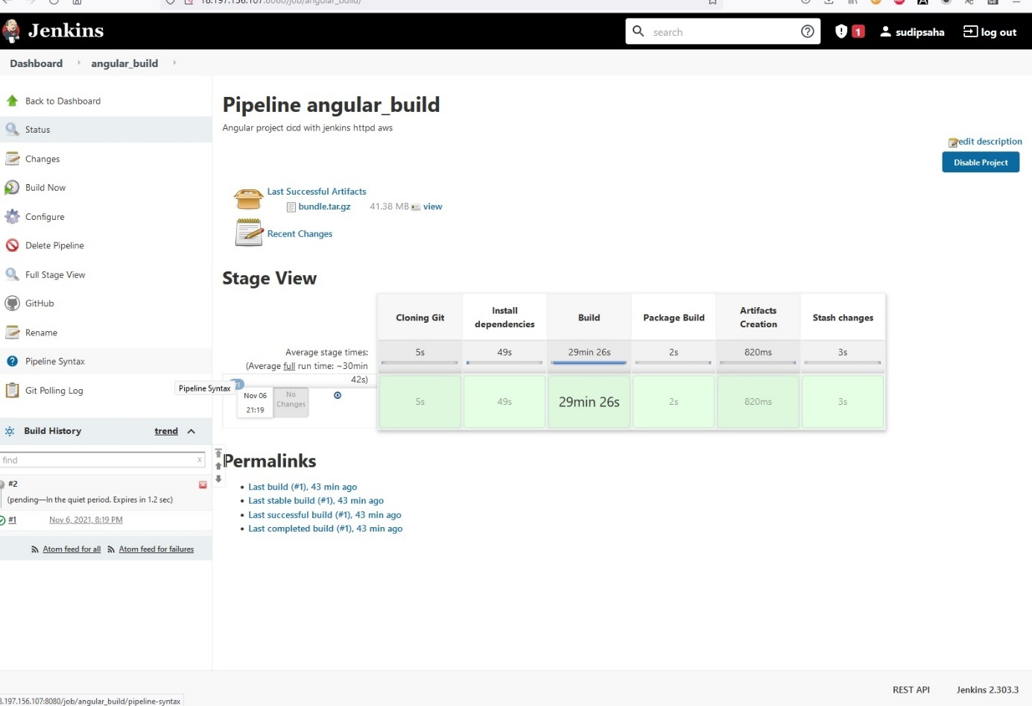

Figure 60:1st successful build of the Angular project

After a change in the GitHub Repository -Jenkins will start build the job again what can be seen in figure 61.

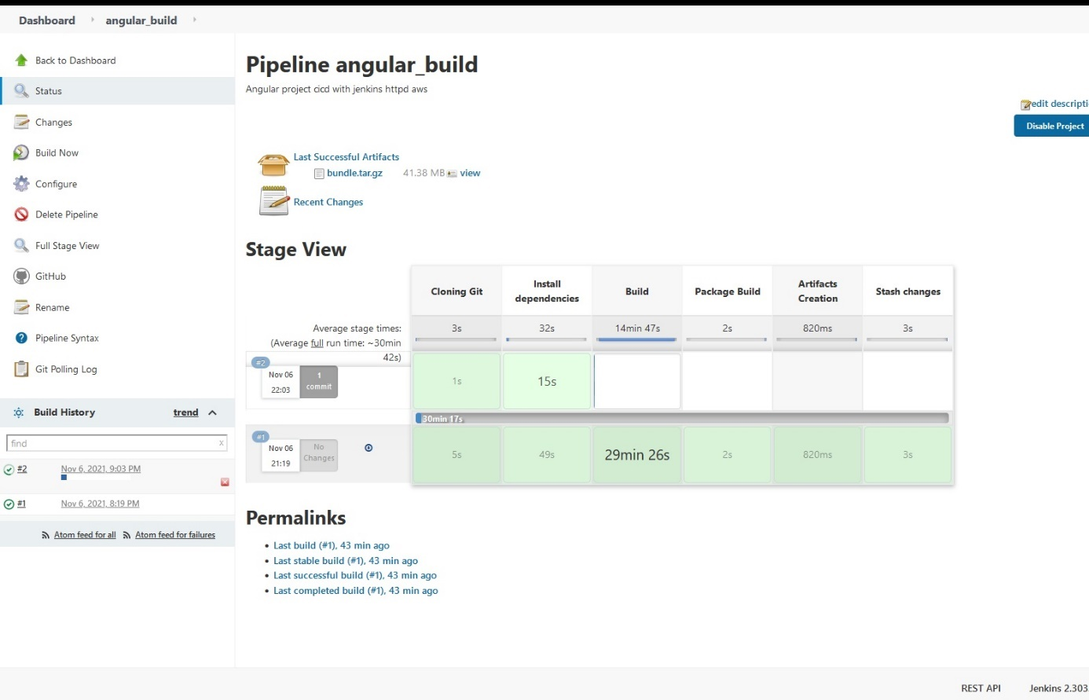

Figure 61: Automatic new build upon change in GitHub Repository

Figure 62-65 demonstrate the successful deployment of the angular project in the httpd Server.

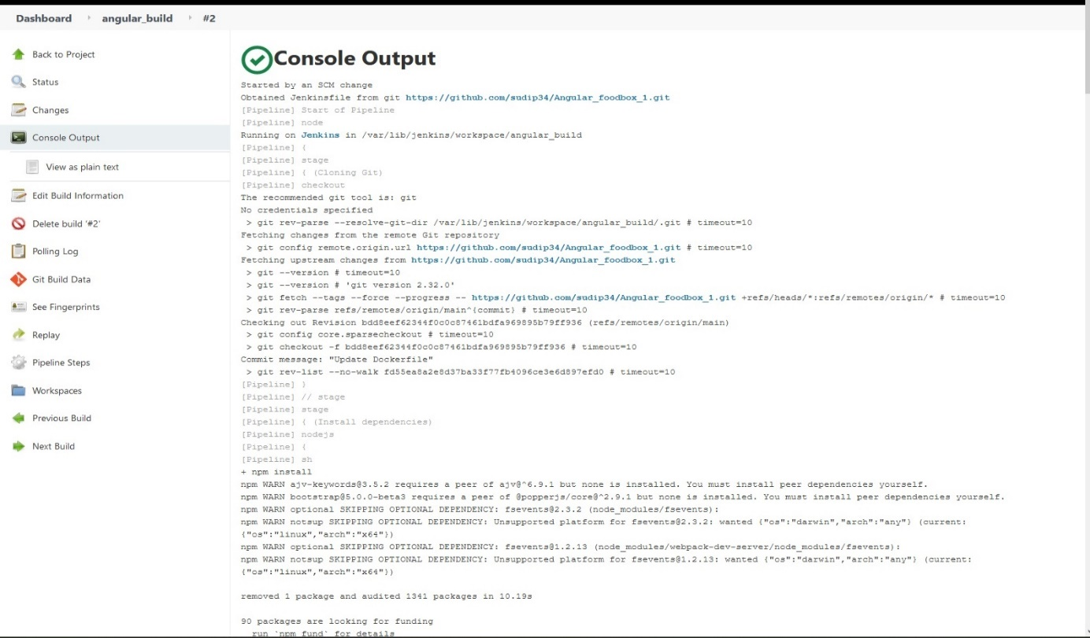

Figure 62: Console Output 1 -angular_build

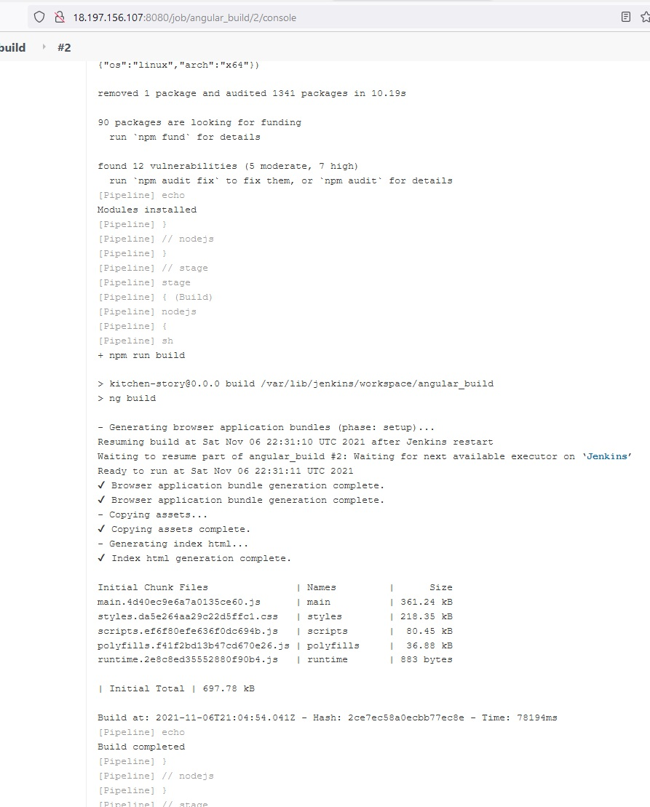

Figure 63: Console Output 2 -angular_build

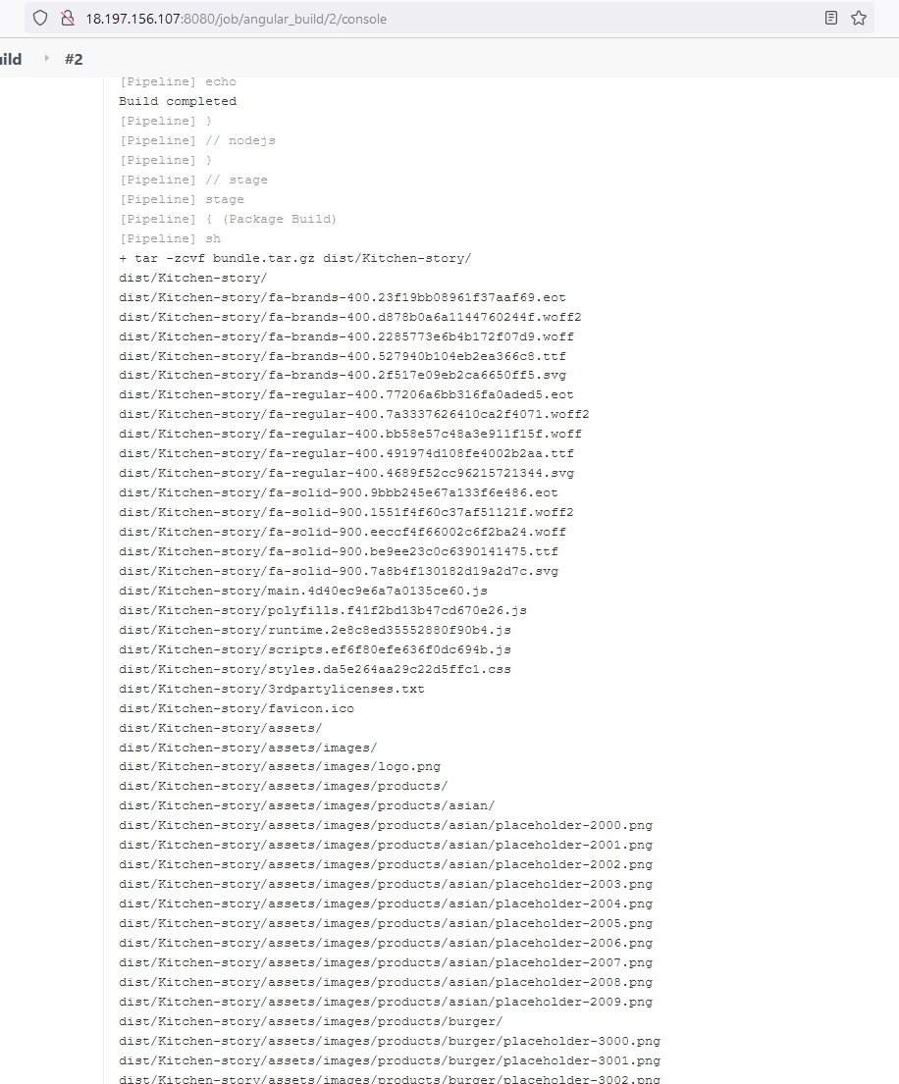

Figure 64: Console Output 3 -angular_build

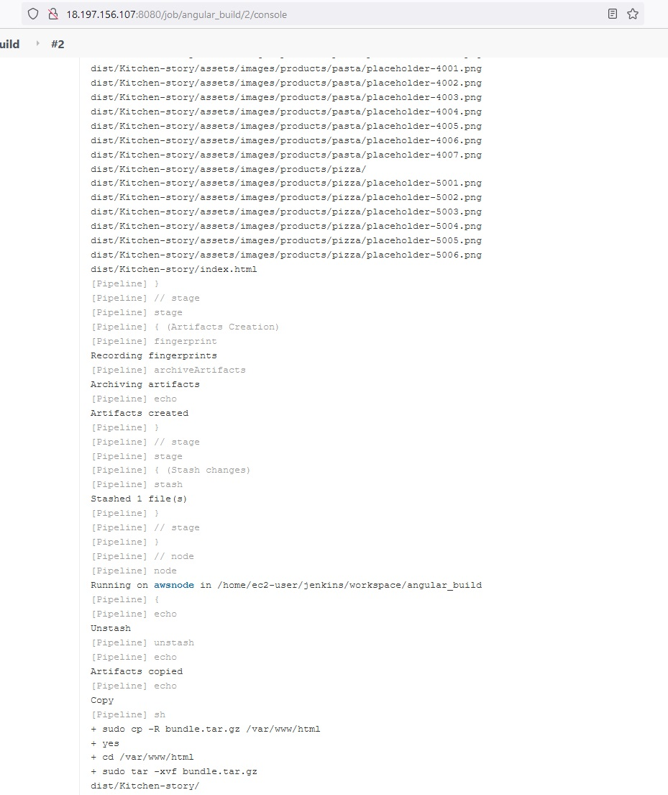

Figure 65: Console Output 4 -angular_build

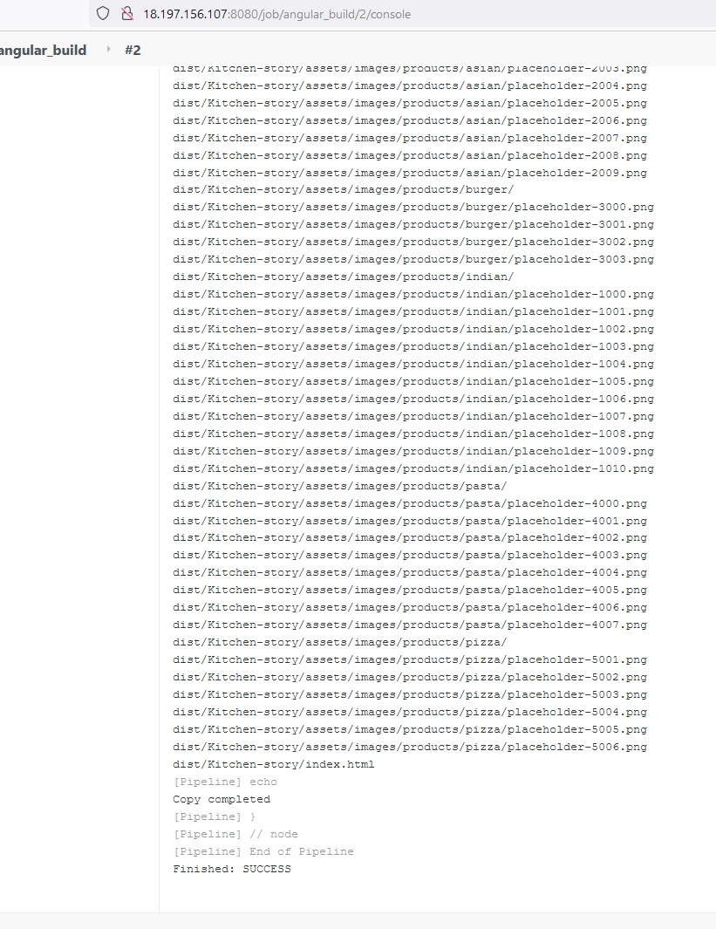

Figure 66: Console Output 5 of the successful build -angular_build